Microsoft Intune Win32 Applications
Zero-to-Advanced Master SOP with Zoom Deployment Example
Plan | Package | Configure | Detect | Assign | Monitor | Troubleshoot | Upgrade

Purpose
This document is designed for an administrator who understands SCCM application deployment but is new to Microsoft Intune. It covers the complete Win32 application lifecycle from source-file preparation to production rollout, monitoring, troubleshooting, supersedence, dependencies, and interview preparation.

Document field | Value
Document owner | Endpoint Management / IT Operations
Platform | Microsoft Intune admin center
Primary app type | Windows app (Win32)
Worked example | Zoom Workplace
Version | 1.0
Prepared date | 23 September 2026
Source screenshots | Attached Apps.docx provided by Dnyaneshwar Karande
Classification | Internal use

1. Intune Application Management Fundamentals

1.1 What is a Win32 app?
A Win32 app is a traditional Windows desktop application packaged as an .intunewin file and delivered by Microsoft Intune. EXE, MSI, scripts, and multi-file installers can be wrapped as Win32 content when the installation can run silently without user interaction.

1.2 Core components
Component | Purpose | SCCM comparison
Source folder | Installer and all required supporting files | Content source
IntuneWinAppUtil.exe | Compresses and encrypts source into .intunewin | Content preparation
.intunewin package | File uploaded to Intune | Distributed application content
Install / uninstall command | Commands executed by the client | Deployment type commands
Requirements | Defines supported OS and architecture | Requirements
Detection rules | Confirms whether app is installed | Detection method
Assignments | Controls Required, Available, or Uninstall targeting | Collection deployment
Intune Management Extension | Downloads, installs, detects, and reports Win32 apps | ConfigMgr client app enforcement

1.3 End-to-end lifecycle
- Confirm business requirement, licensing, architecture, and supported installer.
- Download an enterprise/offline installer from the official vendor source.
- Test silent install and uninstall locally as administrator and, ideally, as SYSTEM.
- Build a clean source folder and package it with Microsoft Win32 Content Prep Tool.
- Create Windows app (Win32) in Intune and upload the .intunewin file.
- Configure app information, commands, requirements, detection, dependencies, supersedence, scope tags, and assignments.
- Deploy to a small pilot group, monitor status and logs, then expand in controlled rings.
- Maintain version, detection, documentation, rollback, and retirement records.
Golden rule
Packaging does not make an interactive installer silent. Before packaging, prove that the vendor installer supports a fully unattended command and returns predictable exit codes.

2. Prerequisites and Application Planning

2.1 Technical prerequisites
- Supported Windows edition and device enrollment in Intune.
- Device is Microsoft Entra registered, joined, hybrid joined, or otherwise supported for Intune Management Extension.
- A role with permission to create, assign, and monitor applications.
- Latest Microsoft Win32 Content Prep Tool and .NET Framework 4.7.2 or later on the packaging workstation.
- A test device and a dedicated pilot user/device group.
- Vendor-approved silent install and uninstall commands.
- At least one reliable detection method.

2.2 App intake checklist
Question | Example for Zoom | Why it matters
Application name and edition | Zoom Workplace | Prevents duplicate or ambiguous records
Target architecture | 64-bit, 32-bit, or ARM64 | Must match requirements and installer
Installer type | Prefer IT Admin MSI for enterprise rollout | MSI supports system-wide deployment and predictable commands
Install context | System | Available to all users and no admin prompt
Silent install command | Validated before upload | Intune does not support interactive prompts
Uninstall command | Validated before upload | Required for lifecycle and Uninstall assignment
Detection method | MSI product code or stable file/registry rule | Controls final success state
Upgrade strategy | Supersedence or vendor auto-update policy | Prevents unmanaged version drift
Rollback plan | Prior package or uninstall | Reduces production risk

2.3 Recommended folder standard
C:\IntuneApps\
Tools\
IntuneWinAppUtil.exe
Sources\
Zoom\
6.x.x\
ZoomInstallerFull.msi
Install.ps1 (only when required)
Uninstall.ps1 (only when required)
Output\
Zoom\
Logs\

Packaging hygiene
Keep IntuneWinAppUtil.exe and the Output folder outside the application source folder. The tool includes all files and subfolders from the source folder in the package, so unnecessary files increase upload and download size.

3. Navigate to Windows Apps and Start Creation
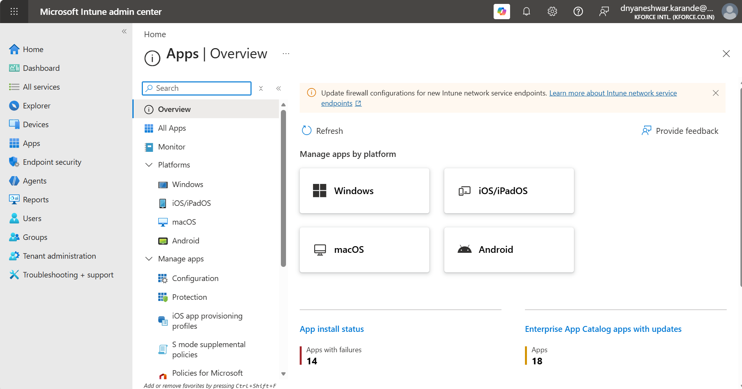
Step 1. In Microsoft Intune admin center, open Apps. The overview shows platforms and app status.
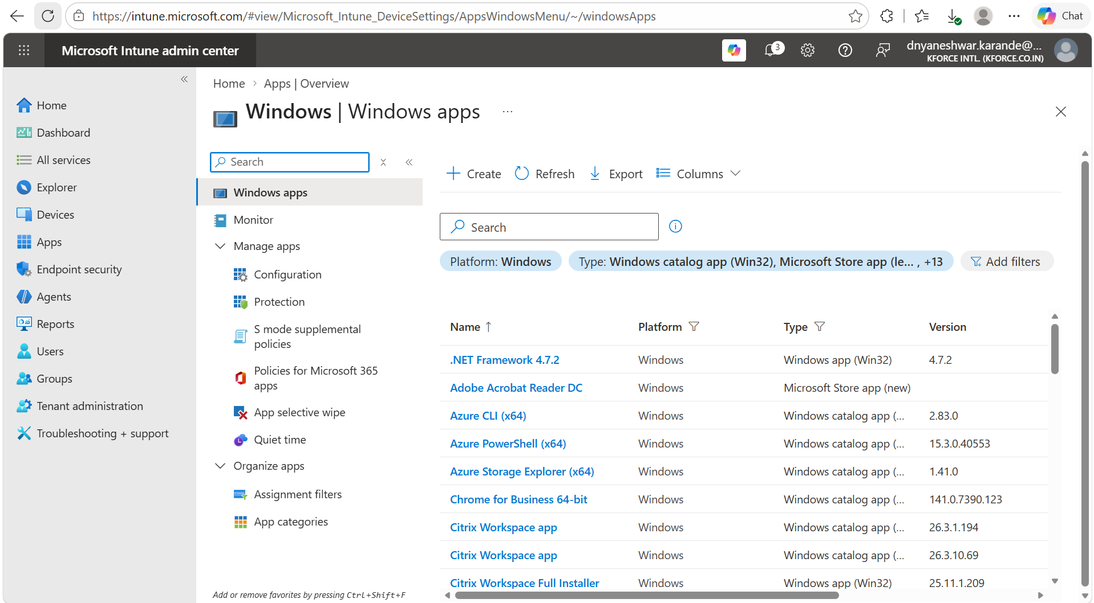
Step 2. Select Windows to open the Windows apps list, then select Create.

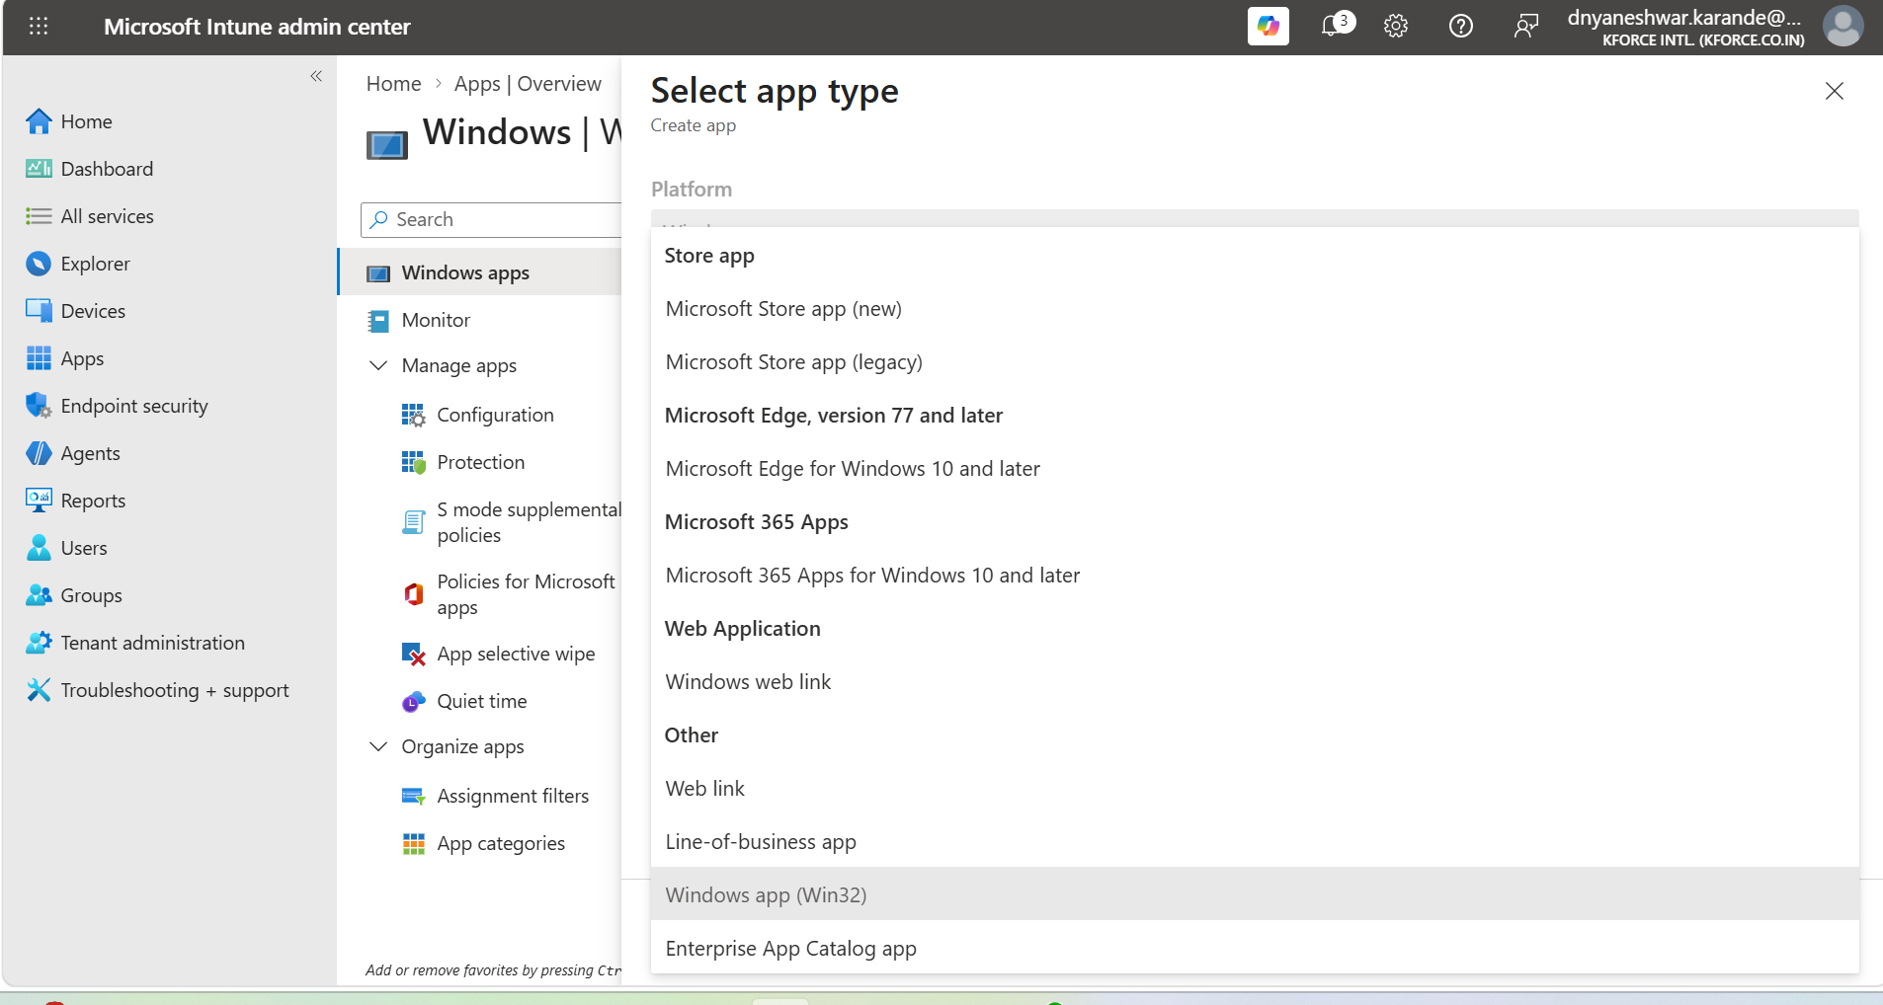
Step 3. Under Windows app, choose Windows app (Win32), then select Select.
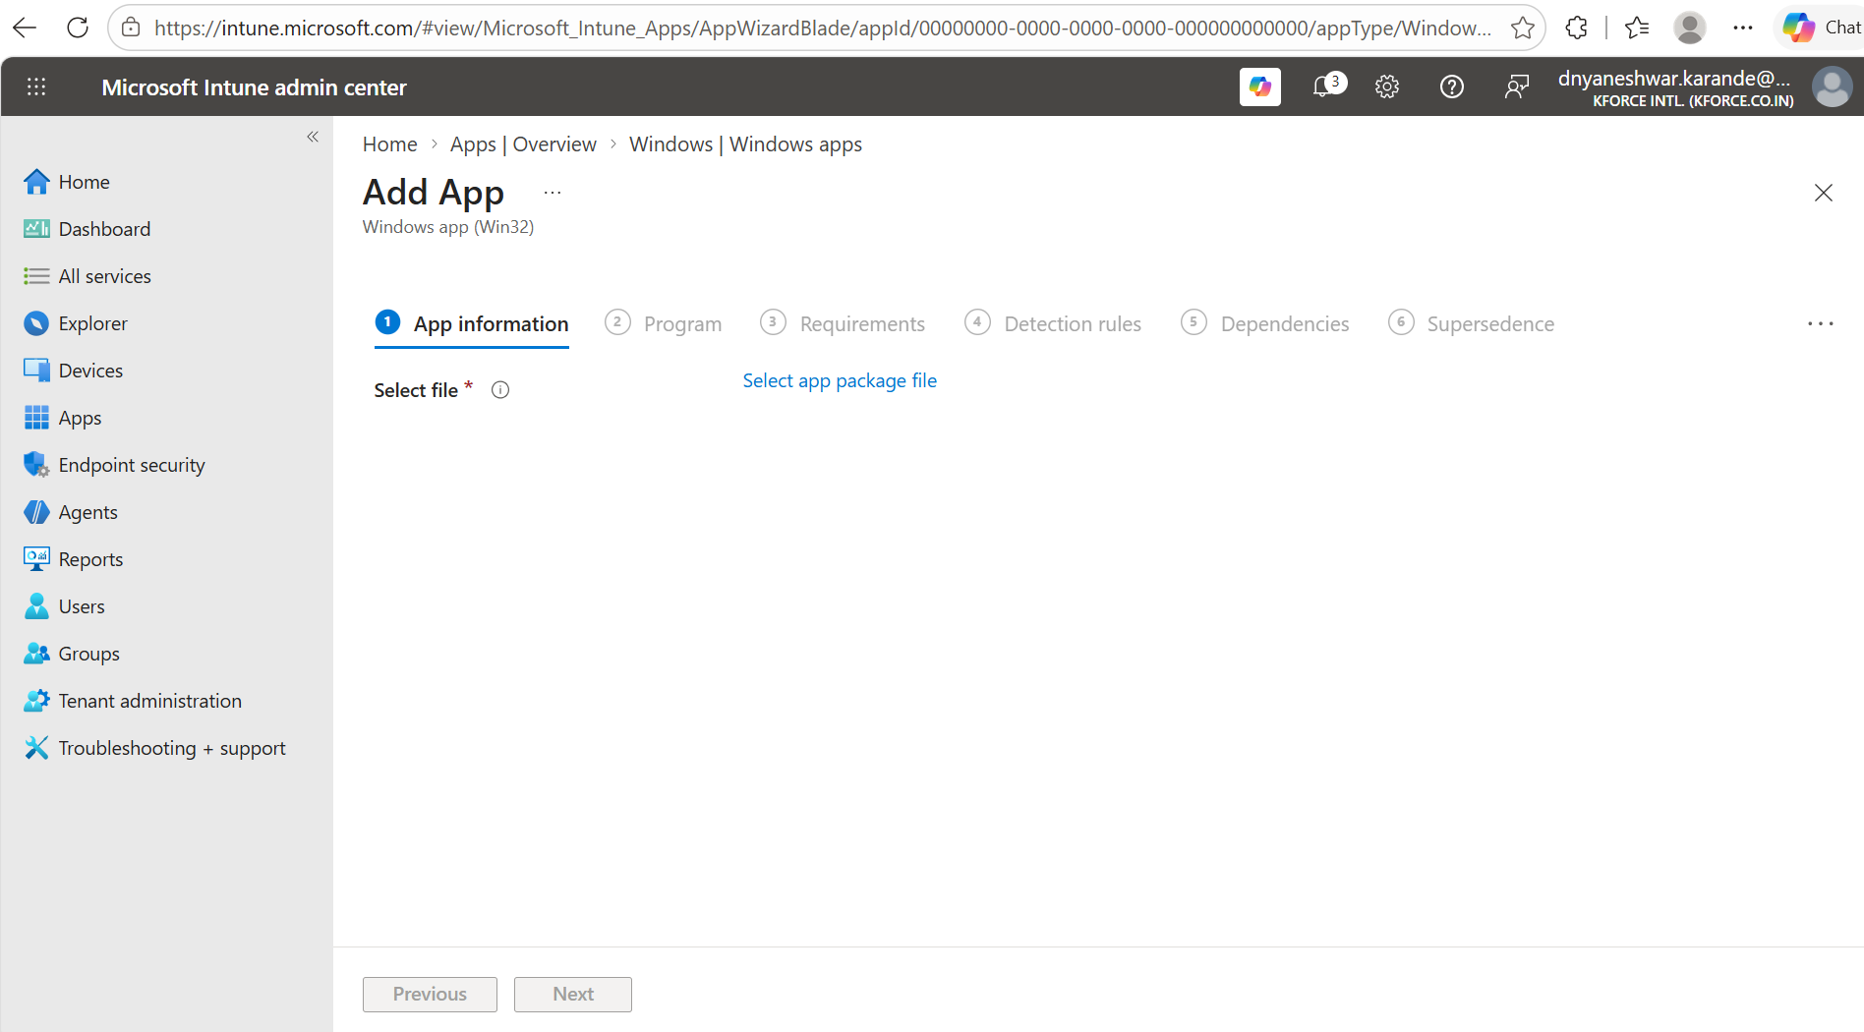
Step 4. The Add app wizard opens. The first task is to upload a prepared .intunewin package.
Current portal note
The exact labels and navigation can change. The logical flow remains: Apps > Windows or All apps > Create > Windows app (Win32).

4. Create the .intunewin Package from Scratch

4.1 Create folders and place the source installer
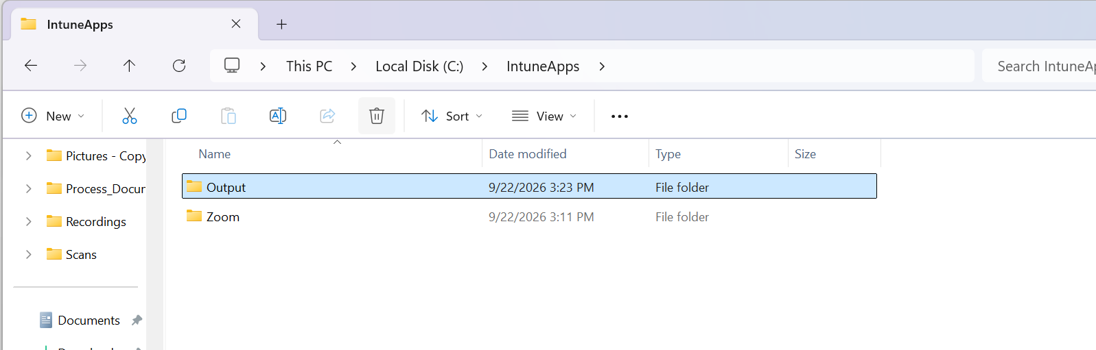
Example folder structure. Source and Output folders are separate under C:\IntuneApps.
- Create C:\IntuneApps\Tools, C:\IntuneApps\Sources\Zoom, and C:\IntuneApps\Output\Zoom.
- Place only the installer and required helper files in the Zoom source folder.
- Rename files cleanly where permitted. Avoid duplicate names such as “(2)” in production packages.
- Confirm file properties, version, architecture, and digital signature.

4.2 Download and run Microsoft Win32 Content Prep Tool
Download IntuneWinAppUtil.exe from the official Microsoft GitHub repository and save it under C:\IntuneApps\Tools. Open Command Prompt as administrator and use either interactive or command-line mode.
cd /d C:\IntuneApps\Tools
IntuneWinAppUtil.exe -v
IntuneWinAppUtil.exe -h

4.3 Interactive mode
IntuneWinAppUtil.exe

Please specify the source folder: C:\IntuneApps\Sources\Zoom
Please specify the setup file: ZoomInstallerFull.msi
Please specify the output folder: C:\IntuneApps\Output\Zoom
Do you want to specify catalog folder (Y/N)? N

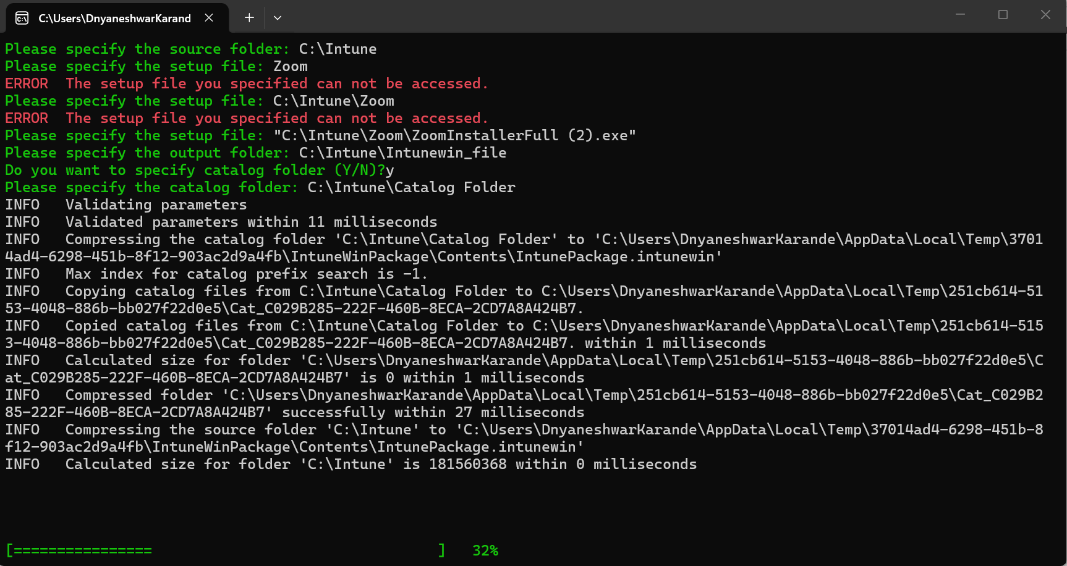
Interactive packaging example. Enter the complete source folder, setup file, and separate output folder. Correct any inaccessible-path errors before continuing.

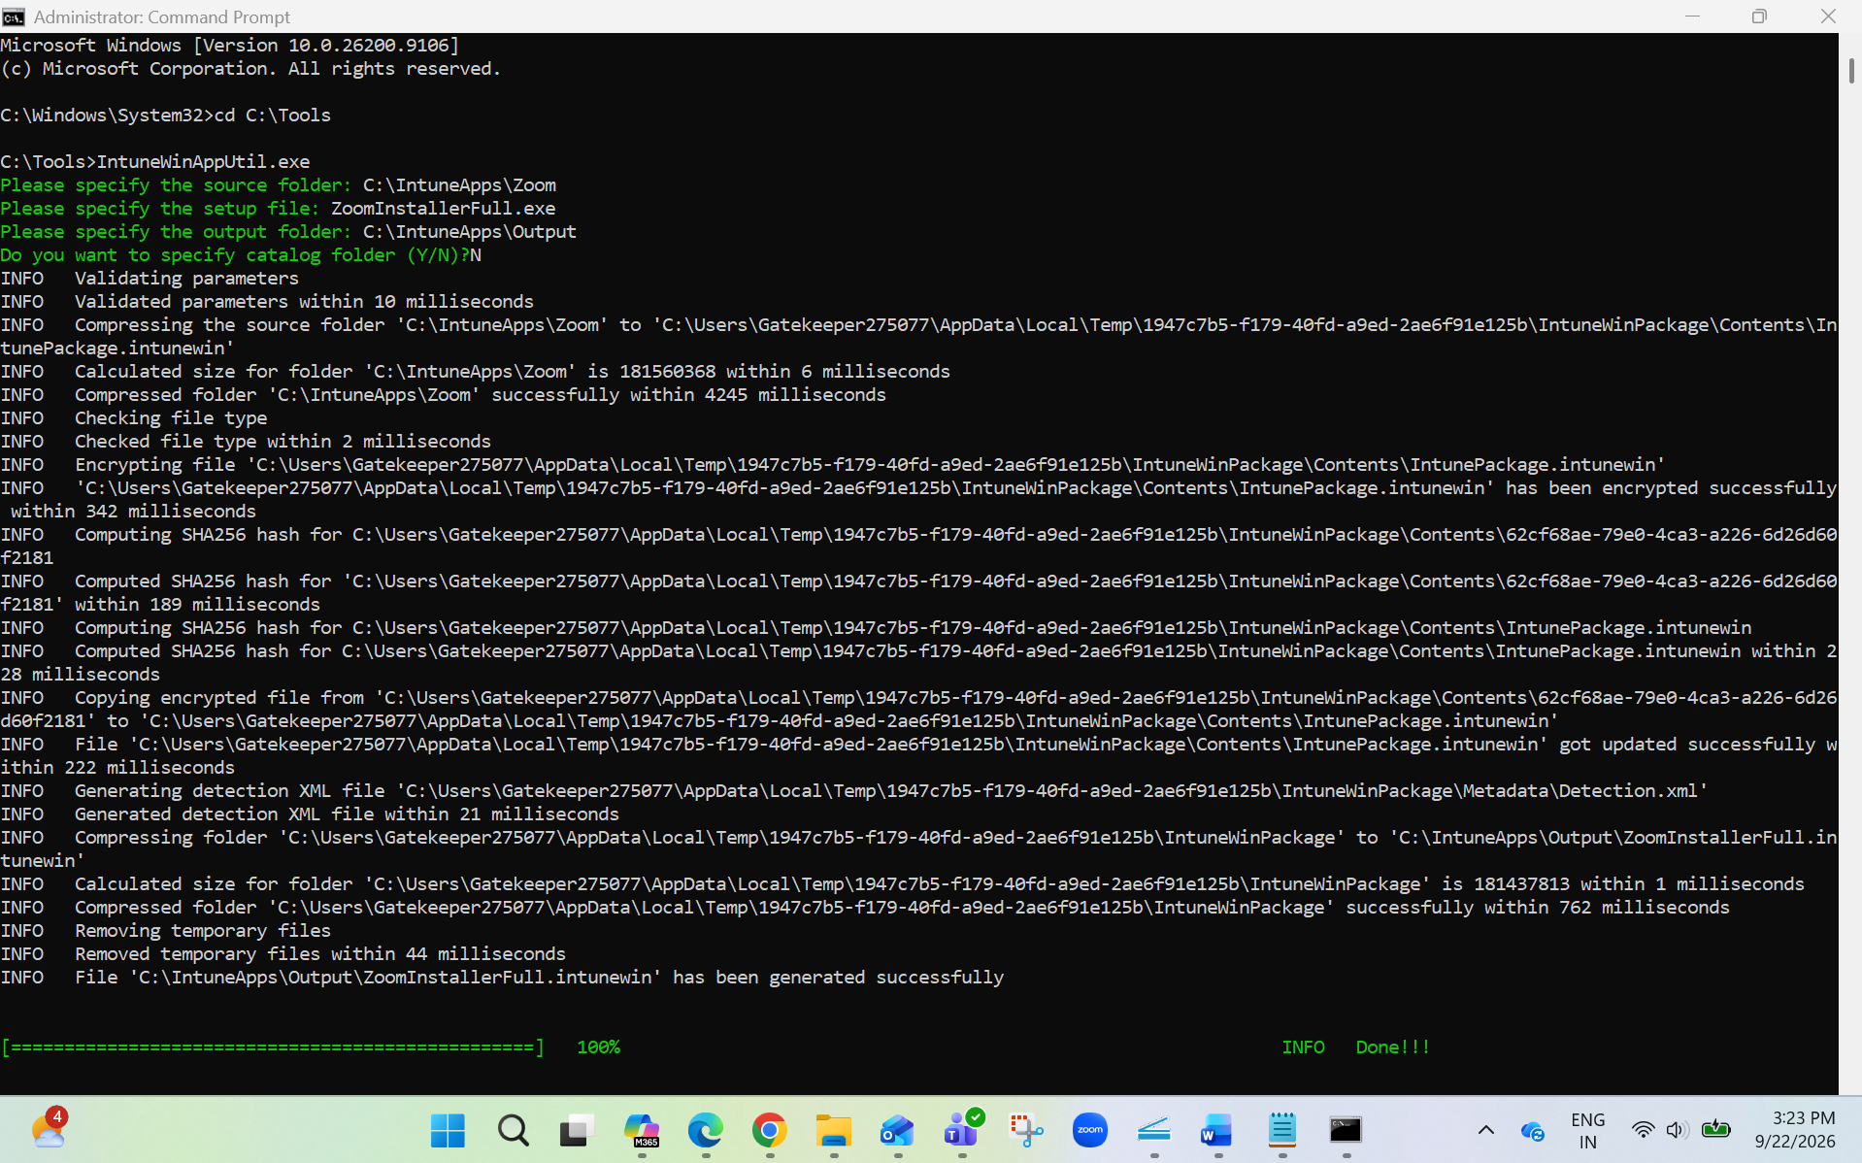
Successful processing shows compression, encryption, package generation, and completion details.
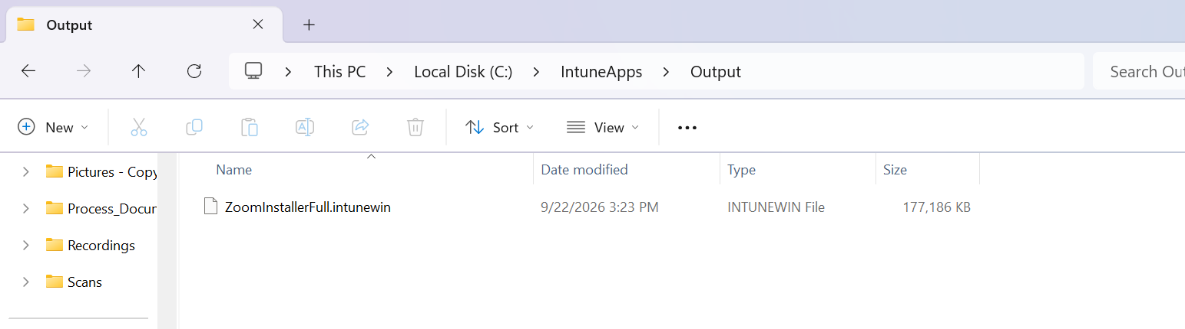
The Output folder contains the generated .intunewin package.

4.4 Recommended one-line command
IntuneWinAppUtil.exe -c "C:\IntuneApps\Sources\Zoom" -s "ZoomInstallerFull.msi" -o "C:\IntuneApps\Output\Zoom" -q

Meaning of parameters
-c specifies the source folder, -s specifies the primary setup file inside the source folder, -o specifies the output folder, and -q runs quiet mode. The output folder is created automatically if it does not exist.

4.5 Common packaging mistakes
- Typing C:\Intune when the actual source is C:\IntuneApps\Sources\Zoom.
- Entering the complete setup-file path at the setup-file prompt instead of only the file name.
- Placing the Output folder inside Source, causing previous packages to be included.
- Packaging a web stub that downloads content during installation. Prefer full/offline enterprise installers.
- Using an untested silent command. Packaging success does not prove installation success.

5. Upload the App Package
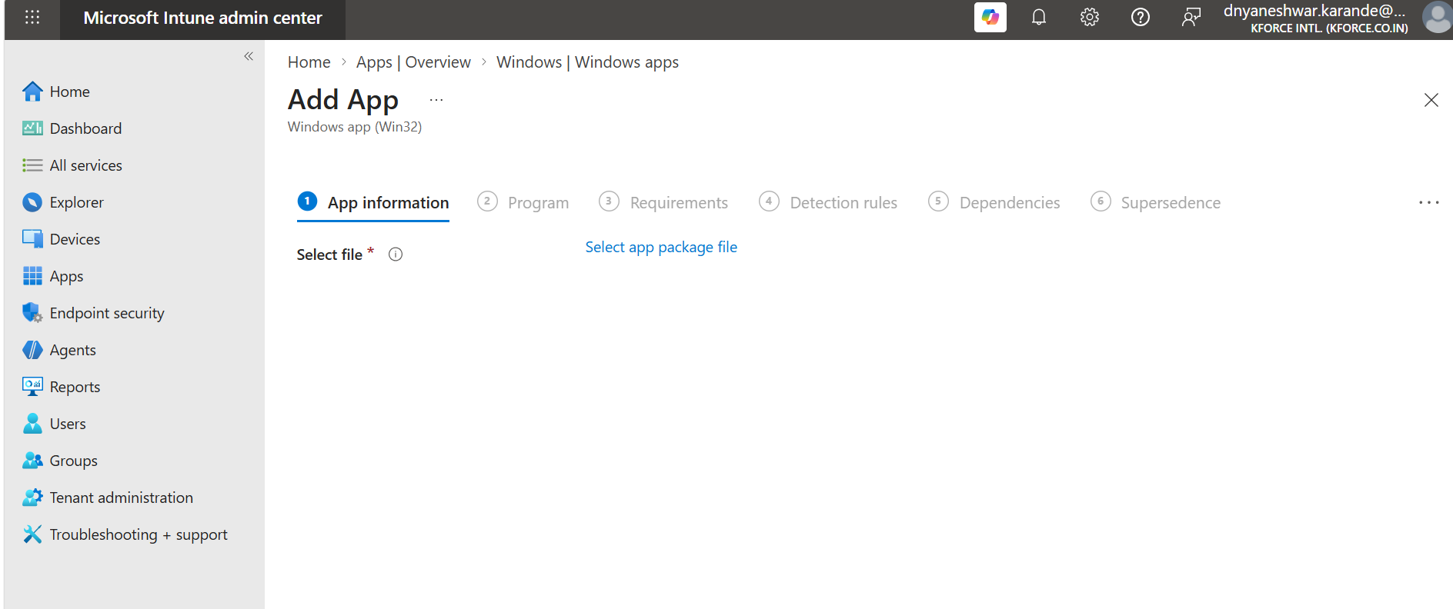
Select app package file on the App information step.
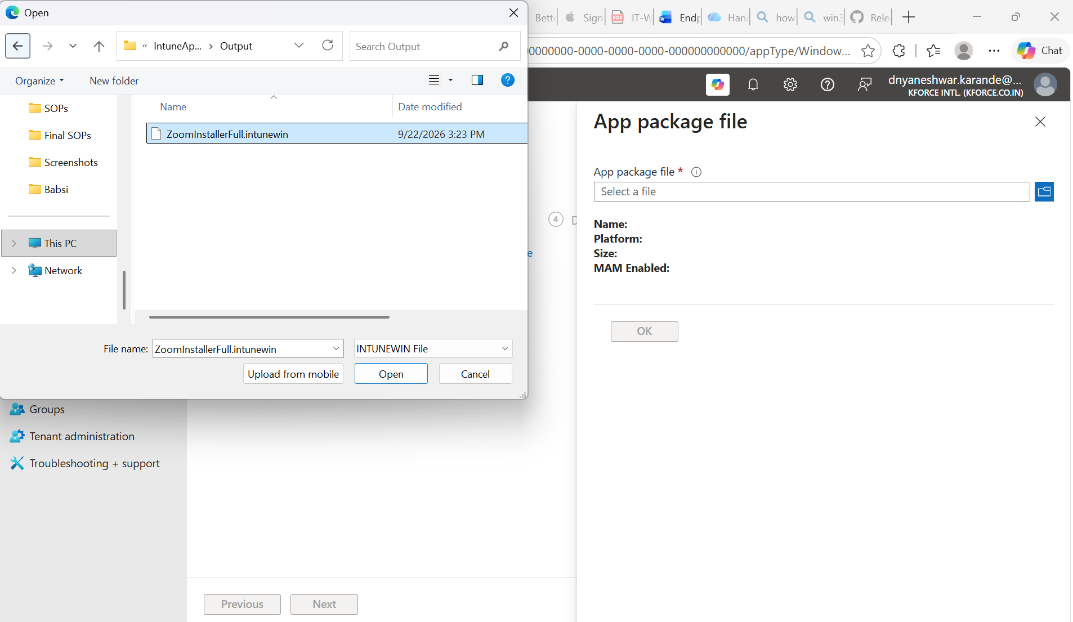
Browse to the Output folder and select the .intunewin file.
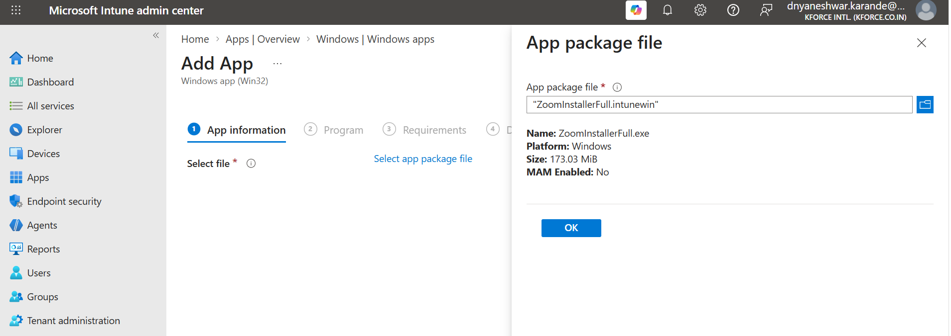
Review package metadata and select OK.
Package selection check
Confirm the setup file, publisher, and package size before selecting OK. If the uploaded package is wrong, go back and upload the correct package instead of compensating with incorrect commands.

6. Configure App Information
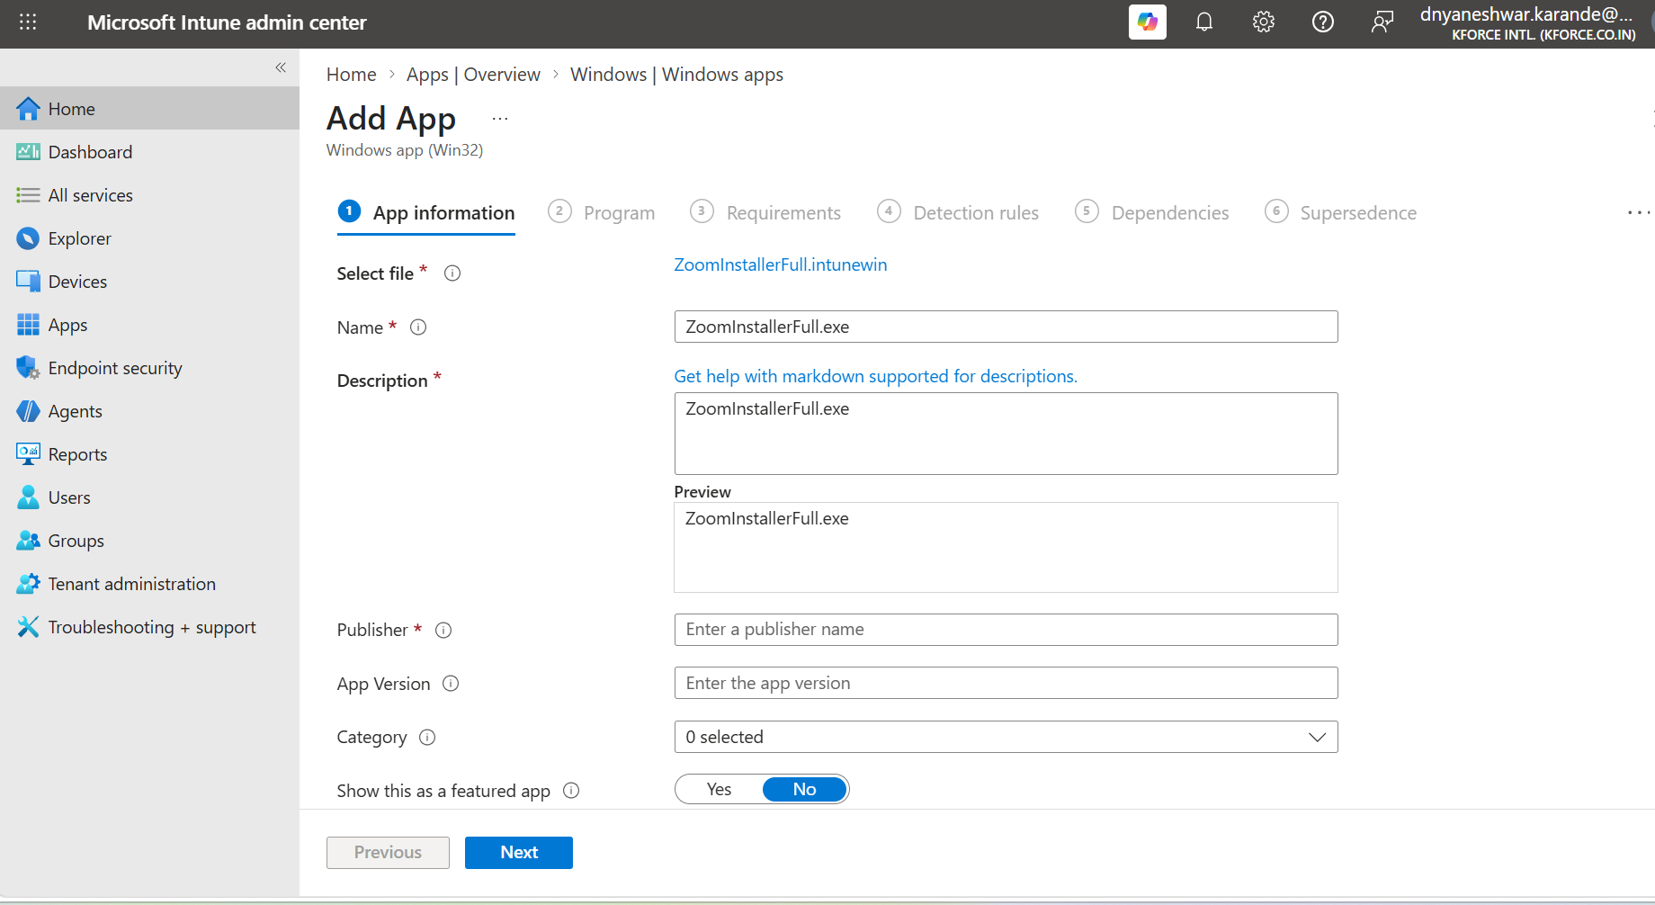
Complete App information. Fields marked with an asterisk are mandatory.
Field | Recommended entry for Zoom | Guidance
Name | Zoom Workplace 64-bit | Include edition or architecture only when useful
Description | Corporate Zoom Workplace client for managed Windows devices | State business purpose and support owner
Publisher | Zoom Communications, Inc. | Use official publisher name
App version | Actual installer version | Helps inventory and change control
Category | Productivity or Collaboration | Improves Company Portal browsing
Show as featured app | No, unless business-approved | Use selectively
Information URL | Official support/product page | Optional but useful
Privacy URL | Official vendor privacy page | Optional
Developer / Owner | Endpoint Management | Supports internal ownership
Notes | Ticket, package date, commands, detection, source URL | Supports future administrators
Logo | Approved product icon | Improves Company Portal experience
Naming standard example
Publisher - Product - Edition - Architecture - Version
Example: Zoom - Workplace - 64-bit - 6.x.x

7. Program: Install, Uninstall, Context, and Return Codes
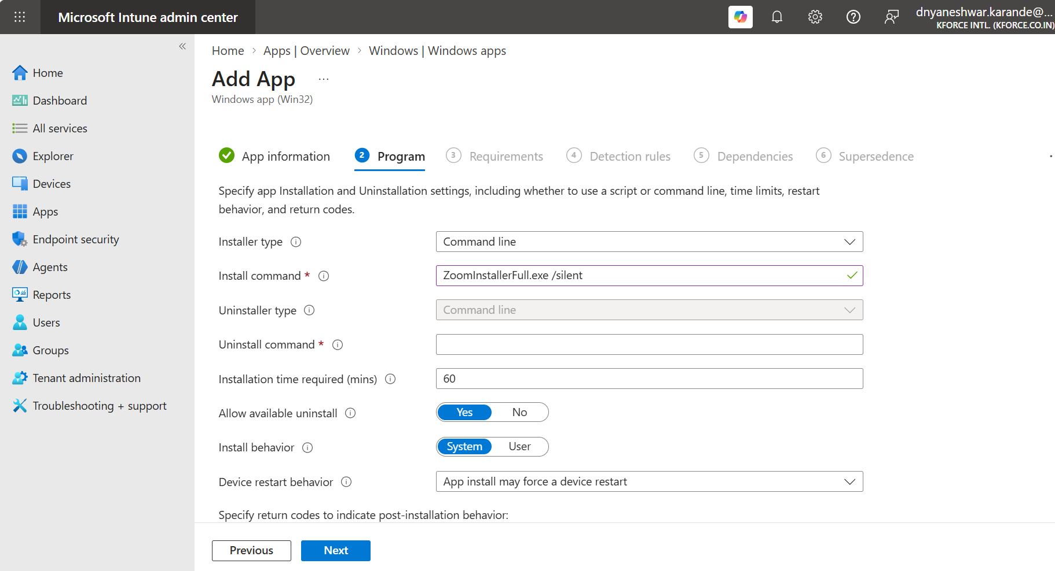
Program page with command-line installer type and basic settings.
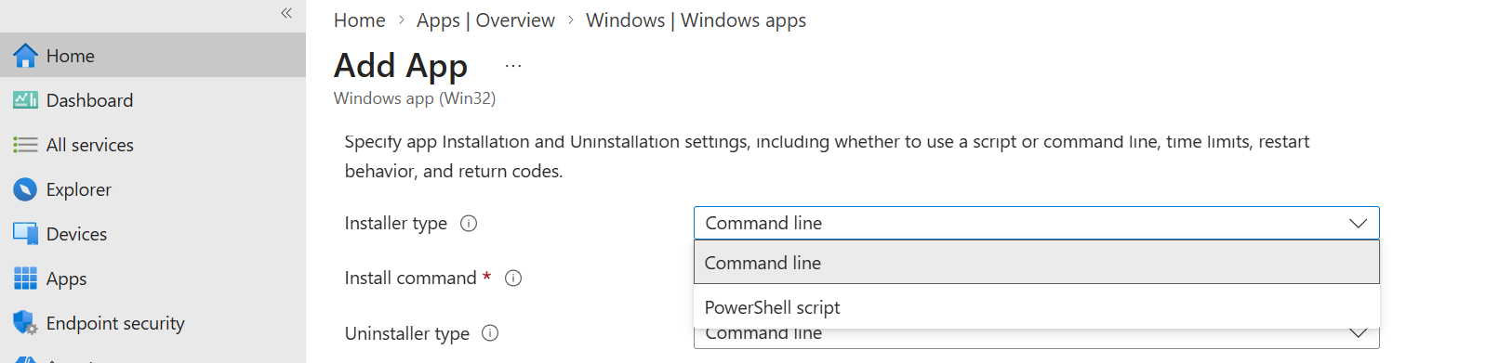
Installer type options can include Command line and PowerShell script, depending on the current portal experience.
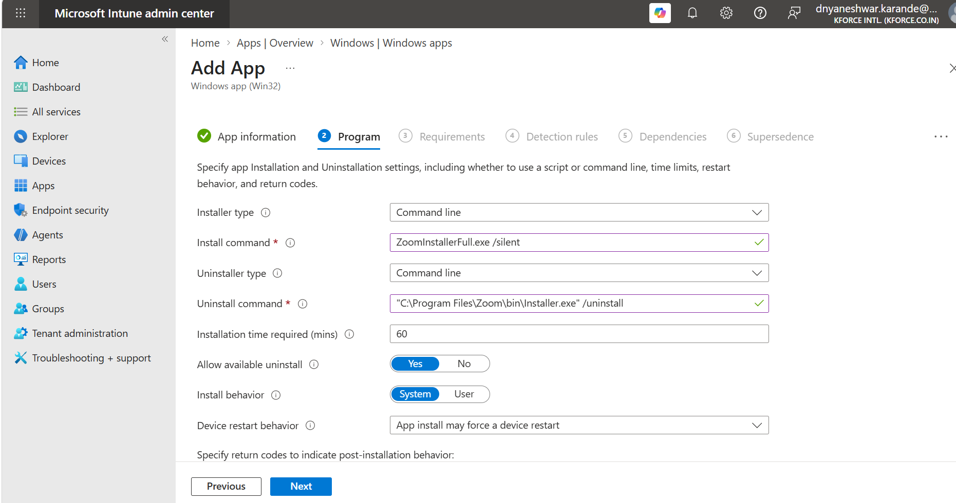
Provide a validated uninstall command and choose installation behavior and restart behavior.

7.1 Recommended Zoom MSI commands
Install command:
msiexec.exe /i "ZoomInstallerFull.msi" /qn /norestart

Uninstall command:
msiexec.exe /x "{PRODUCT-CODE-FROM-THE-MSI}" /qn /norestart

For production, retrieve and verify the actual MSI ProductCode from the selected Zoom MSI or allow Intune to populate MSI metadata where available. Do not paste a placeholder product code into production.

7.2 EXE example shown in the screenshots
Install command example:
ZoomInstallerFull.exe /silent

Uninstall command example from the test screen:
"C:\Program Files\Zoom\bin\Installer.exe" /uninstall

Validate vendor syntax
EXE switches and install locations can change by installer edition and version. Test the exact EXE locally and check its vendor documentation. For enterprise, all-user deployment of Zoom, the IT Admin MSI is usually the safer worked example.

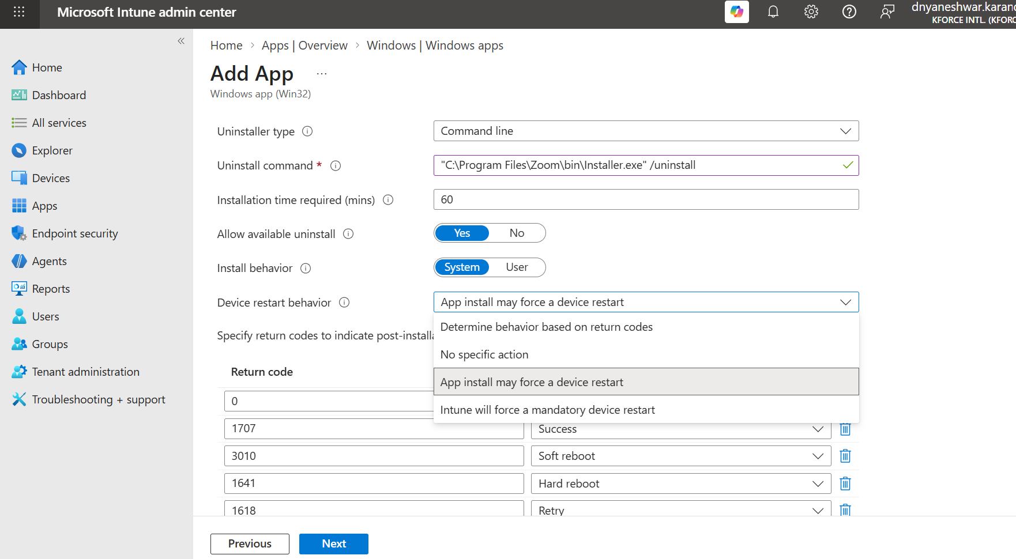
Choose Device restart behavior based on installer behavior and business requirements.
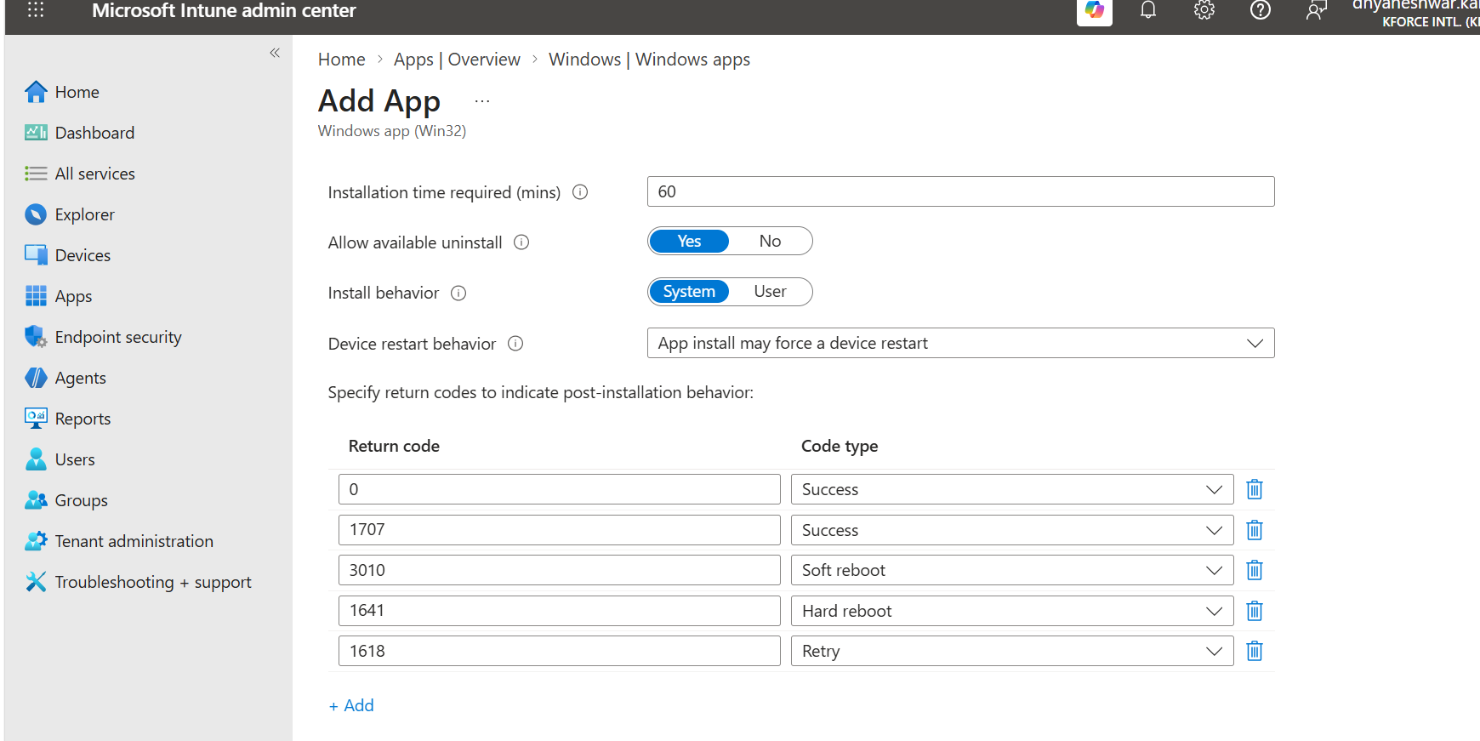
Configure return codes. Default success, soft reboot, hard reboot, retry, and failure mappings should reflect installer behavior.

7.3 Key settings
Setting | Recommended starting point | Explanation
Installation time required | 60 minutes or evidence-based value | IME waits for completion within the configured period
Allow available uninstall | Yes when Company Portal self-service uninstall is approved | Allows end users to uninstall an Available app
Install behavior | System for machine-wide MSI | Runs without user admin rights
Device restart behavior | App install may force a device restart or No specific action | Match the installer and business change window
Return code 0 | Success | Successful installation
Return code 3010 | Soft reboot | Success, restart required
Return code 1641 | Hard reboot | Installer initiated restart
Return code 1618 | Retry | Another installation is in progress

7.4 System vs User context
- System: use for machine-wide software, services, drivers, apps under Program Files, and devices shared by multiple users.
- User: use for true per-user applications installed in user profile locations.
- A SYSTEM-context deployment cannot rely on the administrator’s mapped drives, user profile, or interactive prompts.

8. Requirements
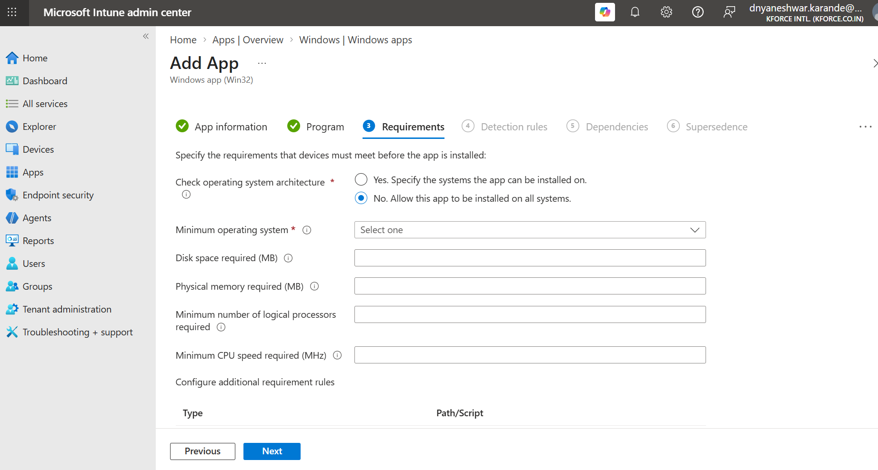
Requirements define which devices are eligible before installation begins.
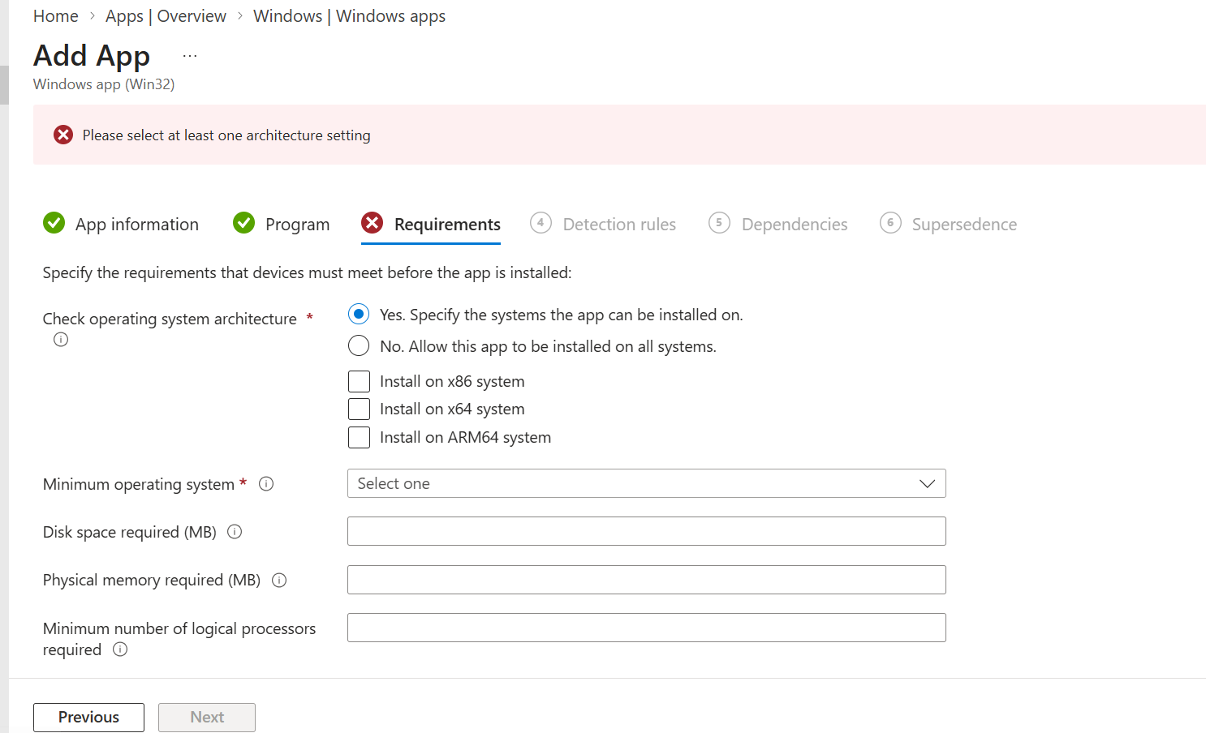
If architecture-specific targeting is selected, choose at least one architecture to avoid the validation error.
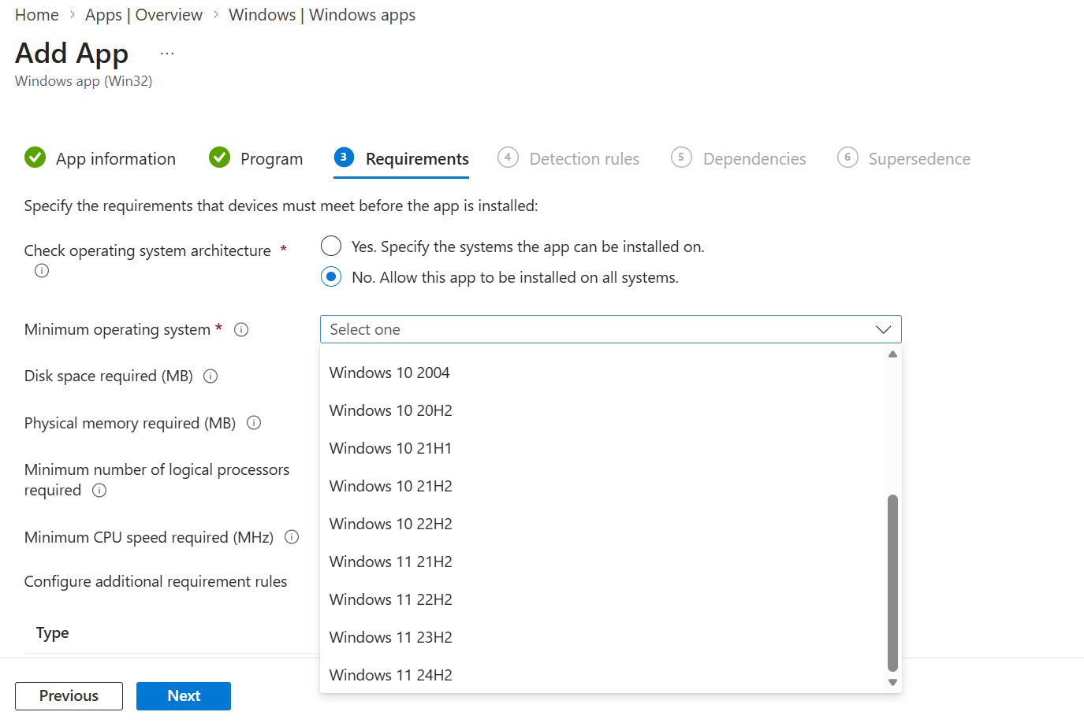
Select the minimum supported operating system from the current list.

8.1 Recommended Zoom 64-bit example
Requirement | Example | Decision guidance
Operating system architecture | 64-bit | Match the package; use ARM64 package for ARM devices
Minimum operating system | Organization-supported Windows baseline | Do not select a version older than security policy
Disk space required | Vendor package plus working space | Optional but useful for large apps
Physical memory | Only if vendor specifies | Avoid unnecessary blocks
Minimum logical processors | Only if vendor specifies | Avoid unnecessary blocks
Minimum CPU speed | Only if vendor specifies | Avoid unnecessary blocks
Additional requirement rule | Script only for a real business condition | Must return supported output and exit behavior
Requirements vs assignments
Assignments answer “who should receive the app.” Requirements answer “is this targeted device technically eligible.” Detection answers “is the app already installed.”

9. Detection Rules: The Most Important Configuration
After the install command exits, Intune evaluates detection rules. If the installer returns success but detection is false, the deployment is reported as failed or may retry. A stable and specific detection rule is therefore essential.
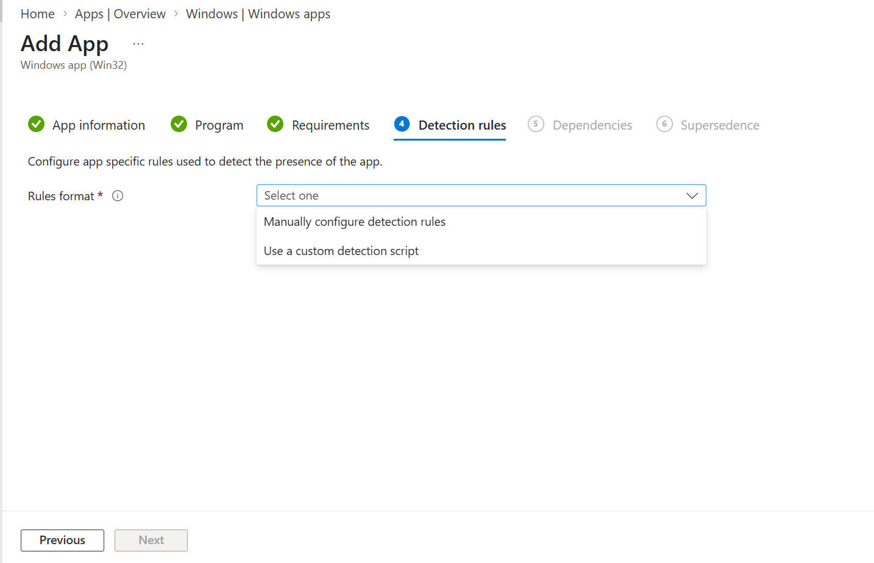
Choose Manual detection rules or a custom detection script.
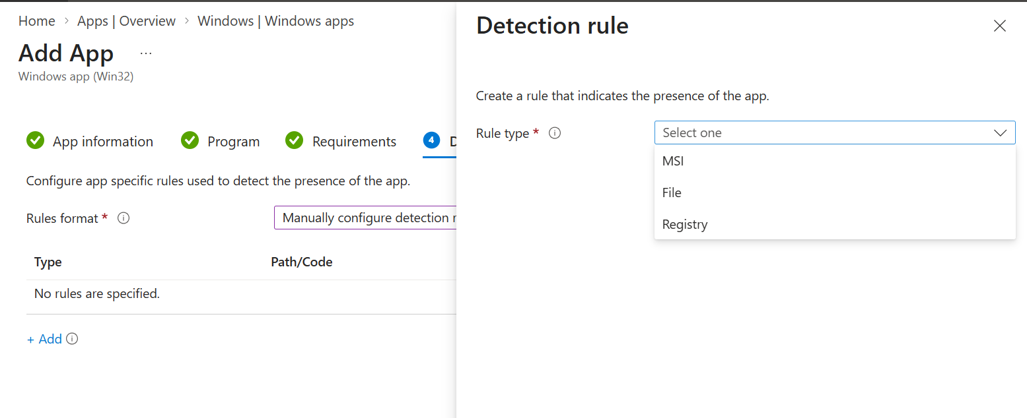
Manual detection rule types include MSI, File, and Registry.
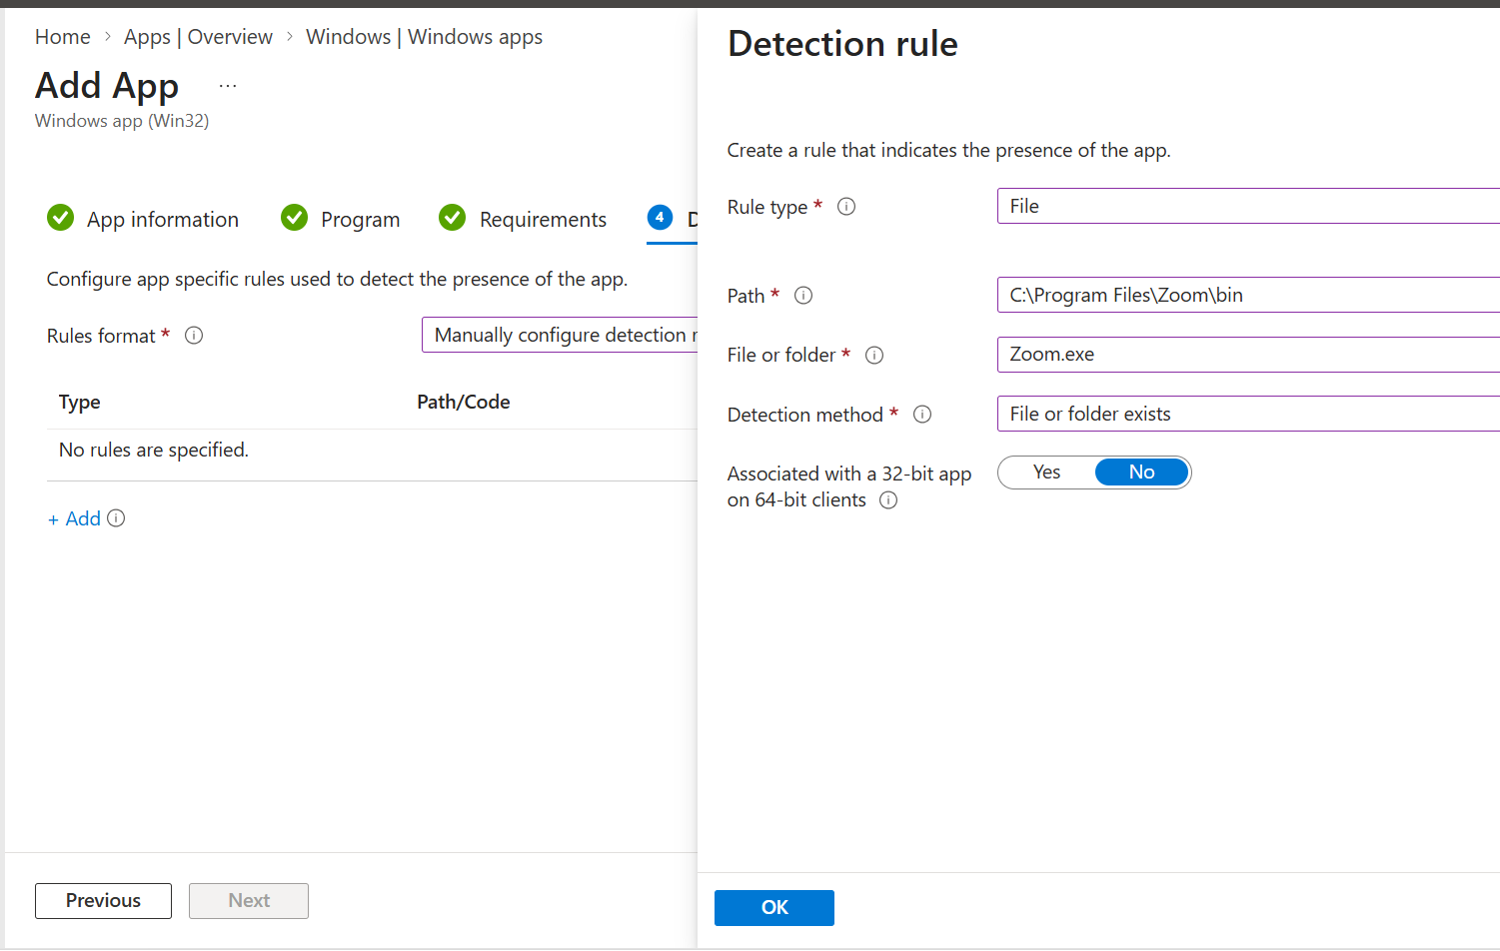
Screenshot example: file detection using C:\Program Files\Zoom\bin and Zoom.exe.
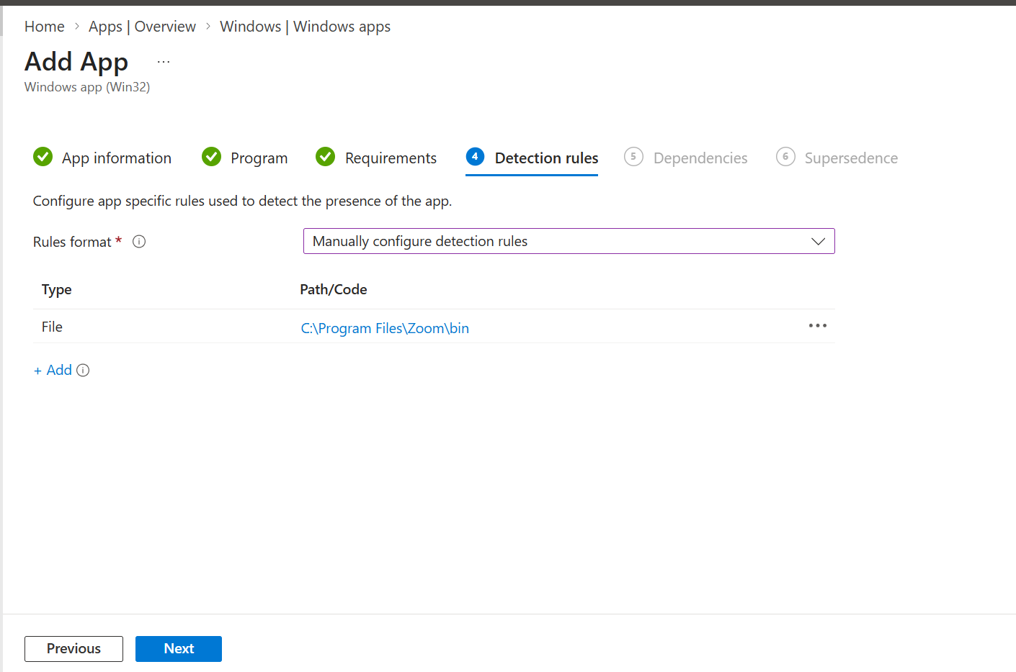
The completed file rule appears in the Detection rules list.

9.1 Detection method decision tree
Installer / scenario | Preferred rule | Why
MSI with stable ProductCode | MSI ProductCode | Simple and reliable for that MSI identity
EXE with stable installed file | File exists or version comparison | Works when no MSI code is available
Application writes stable registry value | Registry value exists or version comparison | Strong for machine-wide products
Complex business logic or multi-condition app | Custom PowerShell detection script | Supports architecture, edition, or version logic
Frequently changing MSI ProductCode | File/registry version or scripted logic | Avoids changing detection every release

9.2 File detection example
Field | Value
Rule type | File
Path | C:\Program Files\Zoom\bin
File or folder | Zoom.exe
Detection method | File or folder exists
Associated with a 32-bit app on 64-bit clients | No for 64-bit Zoom
Detection improvement
“File exists” confirms presence but not version. For upgrade control, use file version greater than or equal to the packaged version, registry display version, MSI version, or a custom script.

9.3 Example custom detection script
$Path = "C:\Program Files\Zoom\bin\Zoom.exe"
if (Test-Path $Path) {
$Version = (Get-Item $Path).VersionInfo.FileVersion
if ([version]$Version -ge [version]"6.0.0.0") {
Write-Output "Zoom detected: $Version"
exit 0
}
}
exit 1

Custom script rule
For Intune custom detection, a successful detection normally requires exit code 0 and output written to STDOUT. Test the script as 64-bit or 32-bit PowerShell exactly as configured.

10. Dependencies and Supersedence
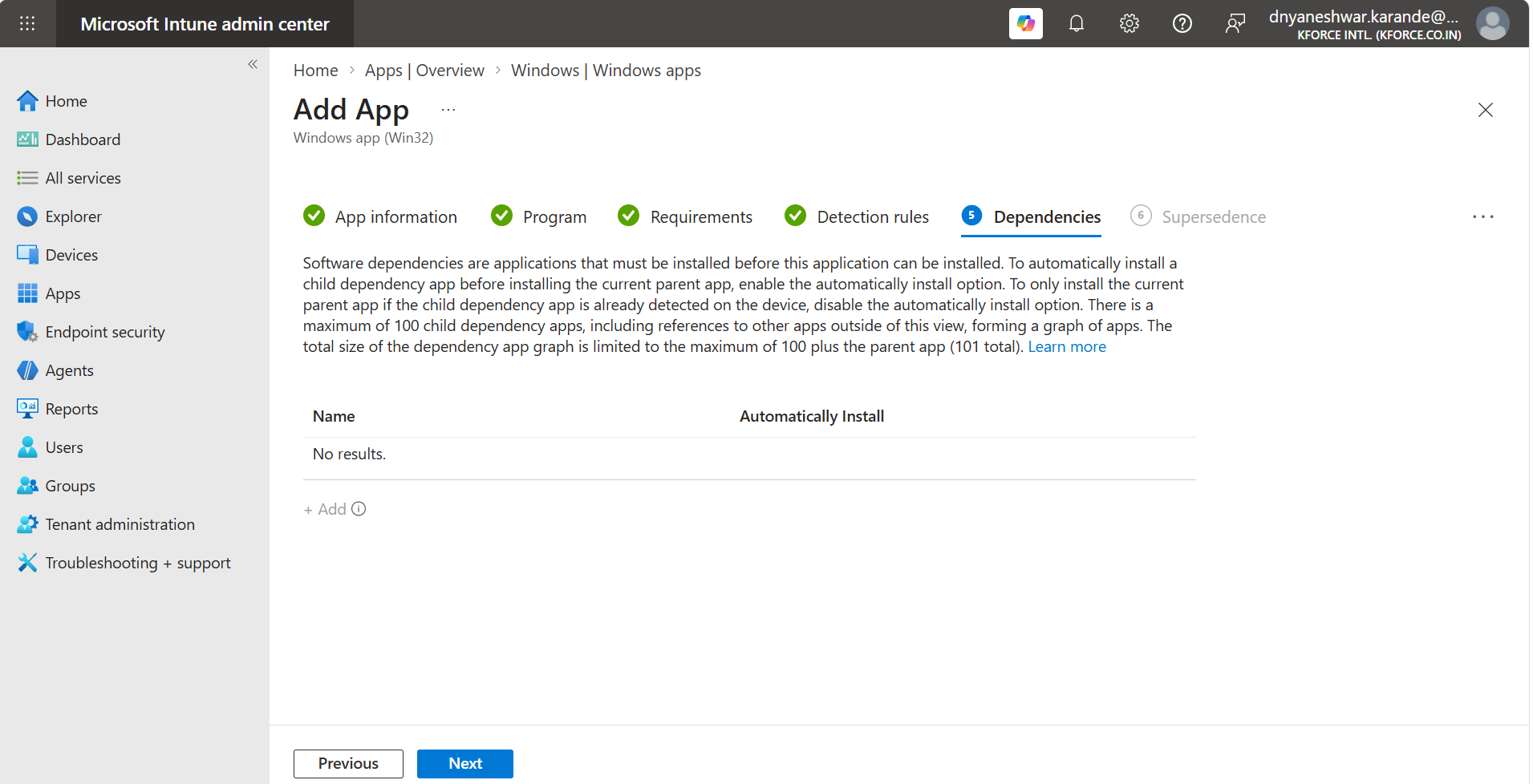
Dependencies page. Add another Win32 app only when the current app requires it.

10.1 Dependencies
- Use a dependency when the primary app requires a runtime, agent, framework, plug-in, or prerequisite app.
- Choose whether Intune should automatically install the dependency.
- Avoid excessive chains. The supported chain depth and total dependency behavior should be checked before complex designs.
- Dependencies must also have correct detection and silent commands.

10.2 Supersedence
- Use supersedence to replace an older Win32 app with a newer app.
- Choose whether the old app must be uninstalled before the new app is installed.
- Use in-place replacement when vendor upgrade behavior is reliable.
- Use uninstall-first when side-by-side installation causes conflict or vendor documentation requires removal.
- Pilot supersedence carefully because detection, assignment, and restart behavior interact.
Dependency vs supersedence
Dependency means “install this prerequisite.” Supersedence means “replace this older application/version.”

11. Assignments, Review, and Creation

11.1 Assignment types
Assignment | Behavior | Typical use
Required | Automatically installs on targeted users/devices | Mandatory corporate applications
Available for enrolled devices | User installs from Company Portal | Optional, self-service software
Uninstall | Removes app from targets when detected | Retirement or access removal

11.2 Safe rollout rings
- Ring 0: Packaging technician or lab device.
- Ring 1: Small IT pilot group.
- Ring 2: Business pilot with representative devices and users.
- Ring 3: Phased production groups.
- Ring 4: Broad deployment after success criteria are met.

11.3 Assignment controls to review
- Include and exclude groups.
- User versus device targeting.
- Availability date and deadline.
- Restart grace period and notifications where available.
- Delivery optimization and bandwidth implications for large packages.
- VPN, proxy, and network requirements.
- Whether the app should be visible in Company Portal.

11.4 Final review checklist
- Correct .intunewin file and setup file.
- Unique, user-friendly name and accurate publisher/version.
- Install and uninstall commands tested locally.
- Correct System or User context.
- Architecture and minimum OS aligned to package.
- Detection rule validated before upload.
- Dependencies and supersedence intentionally configured.
- Pilot group selected; no broad production group accidentally included.
- Support owner, ticket, rollback, and source URL documented.
Do not deploy directly to All users or All devices
For a newly packaged application, always use a test group first. Confirm install, launch, detection, uninstall, reinstall, restart behavior, and upgrade behavior before broad assignment.

12. Monitoring and Validation

12.1 Portal monitoring
- Apps > Windows > select the app > Overview.
- Review Device install status and User install status.
- Open failed records to identify error codes and last check-in.
- Confirm whether the device is targeted, eligible, checked in, and running IME.
- Use Managed apps on the device record for device-specific status.

12.2 Client-side validation
- Sync the device from Company Portal, Windows Settings, or Intune admin center.
- Confirm Microsoft Intune Management Extension service is running.
- Check whether the app installs under System or User context as designed.
- Validate files, registry values, services, shortcuts, and application launch.
- Run the uninstall command and confirm detection becomes false.
- Reinstall to prove the complete lifecycle.

12.3 Important log locations
C:\ProgramData\Microsoft\IntuneManagementExtension\Logs\IntuneManagementExtension.log
C:\ProgramData\Microsoft\IntuneManagementExtension\Logs\AgentExecutor.log
C:\ProgramData\Microsoft\IntuneManagementExtension\Logs\AppWorkload.log

12.4 Support data collection
C:\Program Files (x86)\Microsoft Intune Management Extension\Microsoft.Management.Services.IntuneWindowsAgent.exe

Troubleshooting order
Targeting > requirements > content download > command execution > return code > detection > reporting. Follow this order instead of immediately repackaging the application.

13. Troubleshooting Matrix
Symptom | Likely cause | Action
App not offered or installed | Assignment, licensing, group membership, filter, or requirement issue | Confirm effective targeting, architecture, OS baseline, and device check-in.
Content download fails | Proxy, firewall, disk space, Delivery Optimization, or connectivity | Review IME logs and network path; verify free disk space.
Install command works manually but fails in Intune | Command depends on user profile, current directory, UI, or admin token | Test in SYSTEM context and use relative package paths or full local paths.
Exit code success but Intune reports failure | Detection rule is false | Run the same detection logic after install and correct path, registry view, product code, or version.
Repeated installation attempts | Detection remains false or installer returns retry | Fix detection and inspect return code mapping.
Uninstall fails | Wrong product code, path, quoting, or context | Test uninstall silently and verify exit code and post-uninstall detection.
File rule works on some devices only | 32/64-bit path redirection or edition difference | Check Program Files vs Program Files (x86) and architecture setting.
MSI 1618 | Another installer is running | Keep 1618 mapped to Retry and investigate competing installation workload.
App stuck pending | Device has not checked in, IME issue, dependency pending, or requirement not met | Sync, verify IME service/logs, dependency state, and targeting.
Zoom installs for only one user | Per-user EXE or User context was used | Use vendor IT Admin MSI and System context for machine-wide deployment.
Wrong app version remains | Detection accepts older version | Use version-aware detection and define upgrade/supersedence strategy.
Autopilot app phase delays or fails | Too many required apps, mixed app types, network, or dependency issue | Keep ESP blocking apps minimal and use reliable Win32 packages.

14. Advanced Packaging Patterns

14.1 Wrapper script pattern
Use a PowerShell wrapper when the deployment requires prechecks, process handling, logging, configuration files, cleanup, or multiple commands. The wrapper must remain silent, idempotent, and return meaningful exit codes.
# Install.ps1 example skeleton
$ErrorActionPreference = "Stop"
$Log = "$env:ProgramData\Company\Logs\Zoom-Install.log"
New-Item -ItemType Directory -Path (Split-Path $Log) -Force | Out-Null
Start-Transcript -Path $Log -Append
try {
$p = Start-Process msiexec.exe -ArgumentList '/i "ZoomInstallerFull.msi" /qn /norestart' -Wait -PassThru
if ($p.ExitCode -in 0,3010,1641) { exit $p.ExitCode }
throw "Installer exit code: $($p.ExitCode)"
}
catch {
Write-Error $_
exit 1
}
finally { Stop-Transcript }

Install command when using wrapper:
powershell.exe -NoProfile -ExecutionPolicy Bypass -File .\Install.ps1

14.2 Packaging quality standards
- Idempotent: running install again does not damage the app.
- Silent: no UI, prompts, or user input.
- Deterministic: same source and command produce the same state.
- Observable: package generates useful logs and return codes.
- Detectable: post-install state has a stable detection signal.
- Reversible: uninstall or rollback is documented and tested.
- Secure: package and scripts contain no secrets or unmanaged credentials.

14.3 Version lifecycle
- Record vendor version and package date.
- Keep source installer, scripts, commands, detection logic, and approvals together.
- Compare file/product/registry version during detection where appropriate.
- Use supersedence for controlled replacement and retire old assignments.
- Review vendor auto-update behavior so it does not conflict with Intune deployment strategy.

15. SCCM-to-Intune Mapping and Interview Notes
SCCM concept | Intune equivalent | Important difference
Application | Win32 app | Cloud content upload rather than DP distribution
Deployment Type | Program plus requirements and detection | No separate DT object in the same model
Detection Method | Detection rules | Runs after installation and during reevaluation
Requirements | Requirements | Architecture and OS are common eligibility controls
Dependencies | Dependencies | Win32 dependency relationships
Supersedence | Supersedence | Can replace or uninstall old app
Collection | Microsoft Entra group / assignment filter | Cloud group membership and filters control targeting
Available deployment | Available for enrolled devices | Surfaced in Company Portal
Required deployment | Required assignment | IME enforces installation
Client Center / logs | Intune reports and IME logs | Cloud reporting can have latency
Distribution Point | Microsoft cloud/CDN | Delivery Optimization influences bandwidth

15.1 Interview questions with short answers
Question | Strong answer
Why use Win32 instead of LOB MSI? | Win32 provides richer detection, requirements, dependencies, supersedence, return-code handling, and consistent IME-based delivery.
What is .intunewin? | A compressed and encrypted package created by Microsoft Win32 Content Prep Tool for upload to Intune.
What installs Win32 apps? | Microsoft Intune Management Extension on the managed Windows device.
Why can a successful command still show Failed? | The detection rule may not confirm the installed state.
Required vs Available? | Required installs automatically; Available lets the user install from Company Portal.
System vs User? | System runs machine-wide without user admin rights; User runs in the signed-in user context.
Best detection type? | The most stable and specific signal for the app, often MSI product code, file/registry version, or a custom script.
What is supersedence? | A controlled relationship that replaces an older Win32 app with a newer app, optionally uninstalling the old app.
Where are IME logs? | C:\ProgramData\Microsoft\IntuneManagementExtension\Logs.
How do you troubleshoot? | Validate assignment, requirement, download, execution, return code, detection, and reporting in that order.
Why test as SYSTEM? | Required system-context apps run outside the interactive user session and can behave differently from an admin CMD test.
How do you deploy safely? | Use staged pilot rings, success criteria, monitoring, rollback, and gradual production expansion.

16. Complete Zoom Worked Example

16.1 Recommended source package
- Download the current Zoom Workplace IT Admin MSI matching the required architecture from the official Zoom administrator download source.
- Save it as C:\IntuneApps\Sources\Zoom\<version>\ZoomInstallerFull.msi.
- Record file version, SHA-256 hash if required by change control, download date, vendor URL, architecture, and approval ticket.
- Test installation and uninstallation on a clean test device.

16.2 Local validation
msiexec.exe /i "ZoomInstallerFull.msi" /qn /norestart /L*v "C:\Windows\Temp\Zoom-Install.log"

msiexec.exe /x "{ACTUAL-PRODUCT-CODE}" /qn /norestart /L*v "C:\Windows\Temp\Zoom-Uninstall.log"

16.3 Packaging
C:\IntuneApps\Tools\IntuneWinAppUtil.exe -c "C:\IntuneApps\Sources\Zoom\<version>" -s "ZoomInstallerFull.msi" -o "C:\IntuneApps\Output\Zoom" -q

16.4 Intune configuration summary
Page | Example choice
App information | Zoom Workplace 64-bit; publisher Zoom Communications, Inc.; actual version
Program | MSI quiet install/uninstall; System behavior; 60-minute timeout
Requirements | 64-bit; supported organizational Windows baseline
Detection | MSI product code/version, or stable file version logic
Dependencies | None unless a specific approved prerequisite exists
Supersedence | Replace previous package when upgrade is controlled by Intune
Assignments | Required to lab/pilot first; Available only if self-service is approved
Monitoring | Validate device and user status plus IME logs

16.5 Success criteria
- Package uploads and processes successfully.
- Pilot device is targeted and meets requirements.
- Zoom installs silently with no prompts.
- App launches and required configuration is applied.
- Detection returns installed after installation.
- Uninstall completes silently and detection returns not installed.
- Reinstall works.
- Return codes and restart behavior match documentation.
- Portal status and IME logs show expected outcome.

17. Reusable Application Record Template
Field | Record
Application name
Business owner
Technical owner
Vendor / publisher
Installer type
Installer file and version
Architecture
Vendor source URL
Source hash / signature check
Install command
Uninstall command
Install context
Timeout and restart behavior
Requirements
Detection rule
Dependencies
Superseded app
Pilot group
Production groups
Support logs
Rollback plan
Change / ticket number
Package date and packager

17.1 Pre-production sign-off checklist
- Installer source is trusted and digitally signed.
- License and redistribution terms are understood.
- Silent installation tested.
- Silent uninstallation tested.
- SYSTEM-context test passed when System is selected.
- Detection evaluated before and after install/uninstall.
- Architecture and OS rules validated.
- Upgrade from currently deployed version tested.
- User data and settings behavior reviewed.
- Pilot success criteria approved.
- Rollback and support ownership documented.

18. Screenshot Reference Appendix
The following screenshots are retained from the attached Apps.docx for operational reference. Portal labels may change, so always validate the current tenant experience.
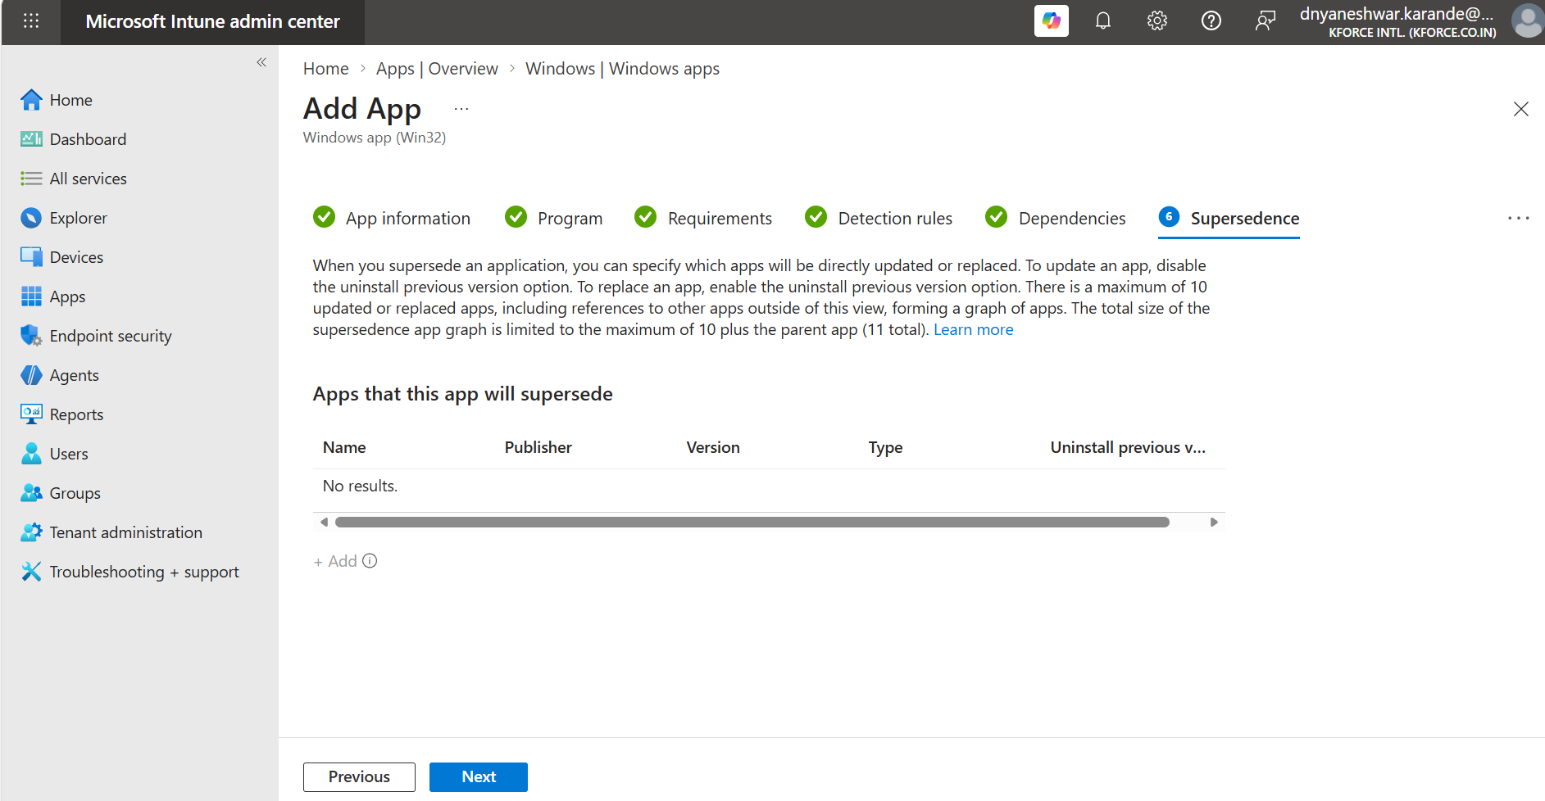
Additional screenshot reference 26. Retained from the attached working document.
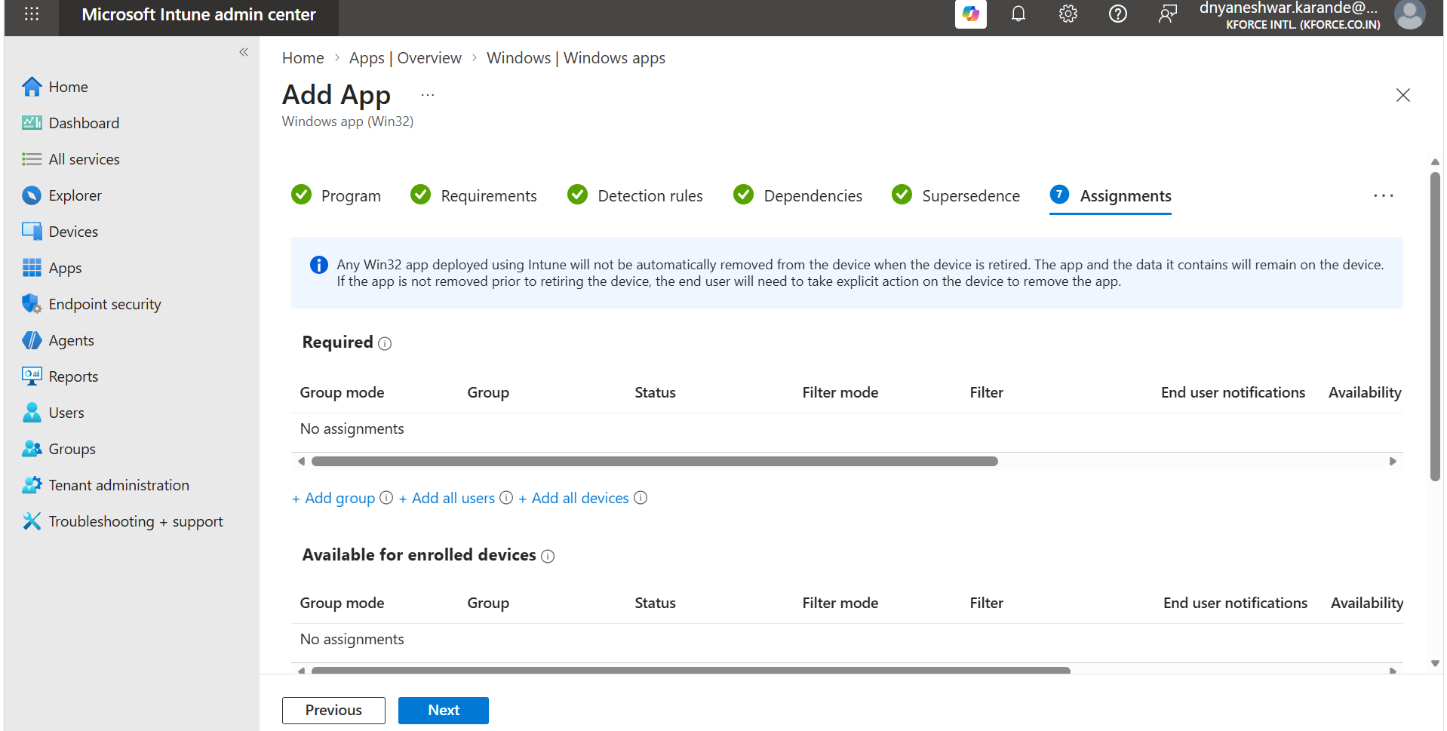
Additional screenshot reference 27. Retained from the attached working document.

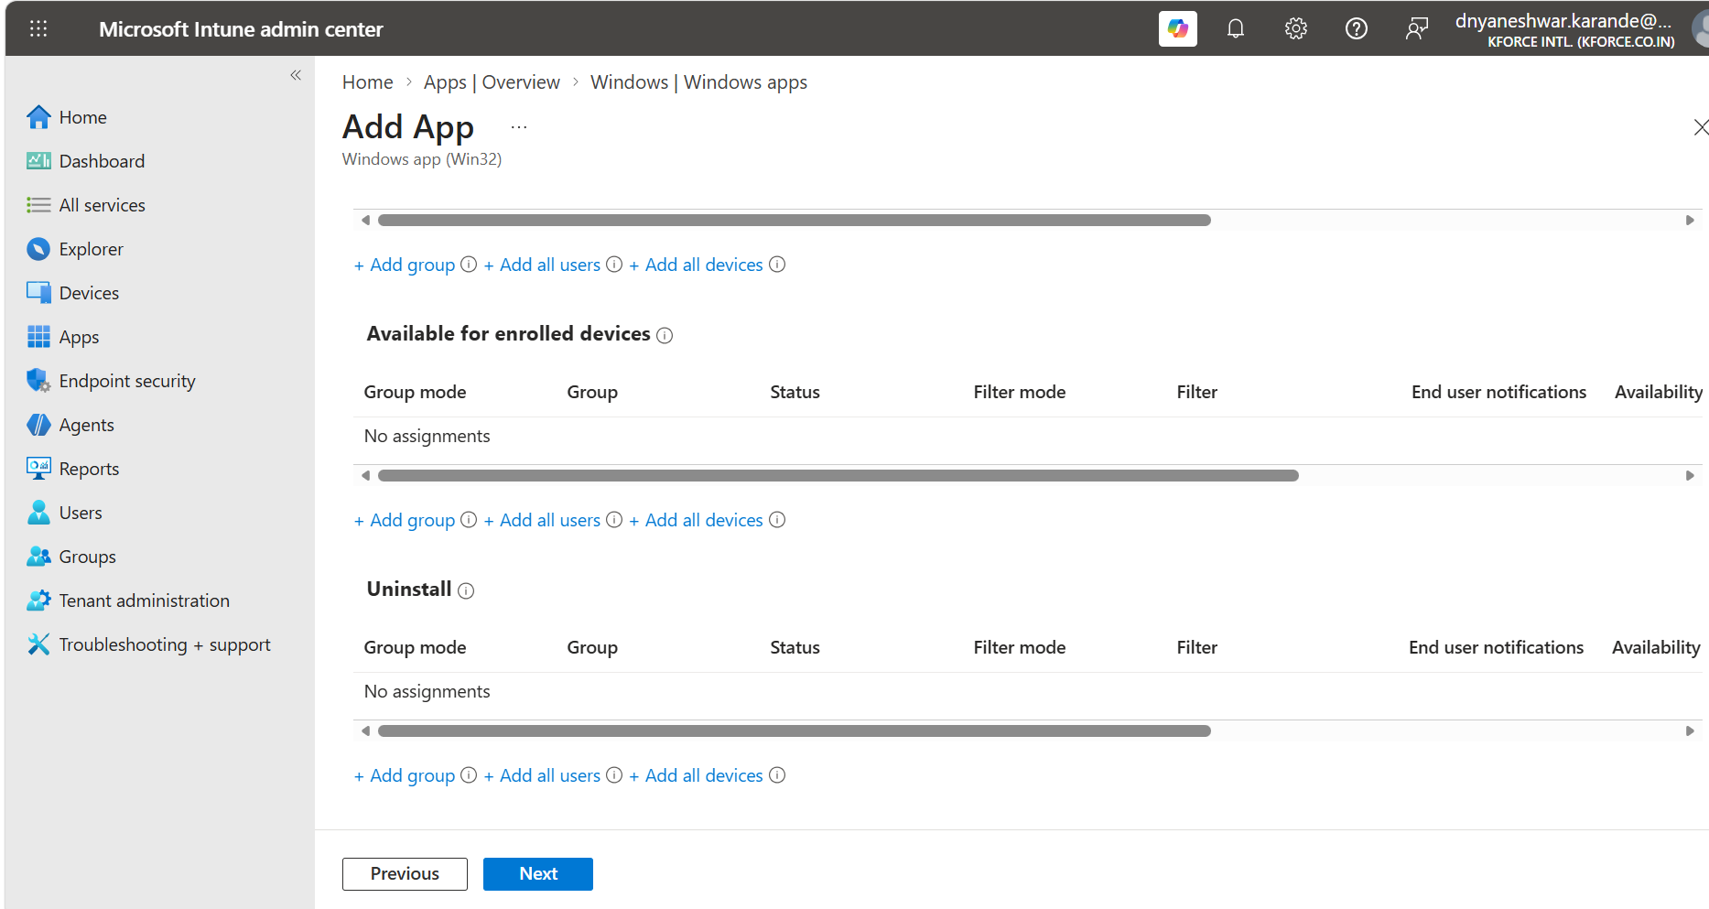
Additional screenshot reference 28. Retained from the attached working document.
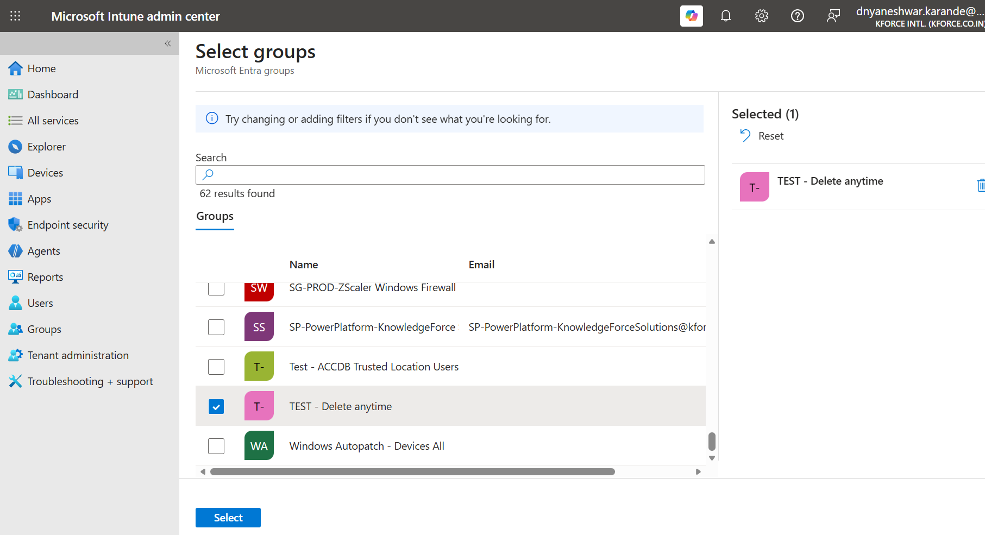
Additional screenshot reference 29. Retained from the attached working document.

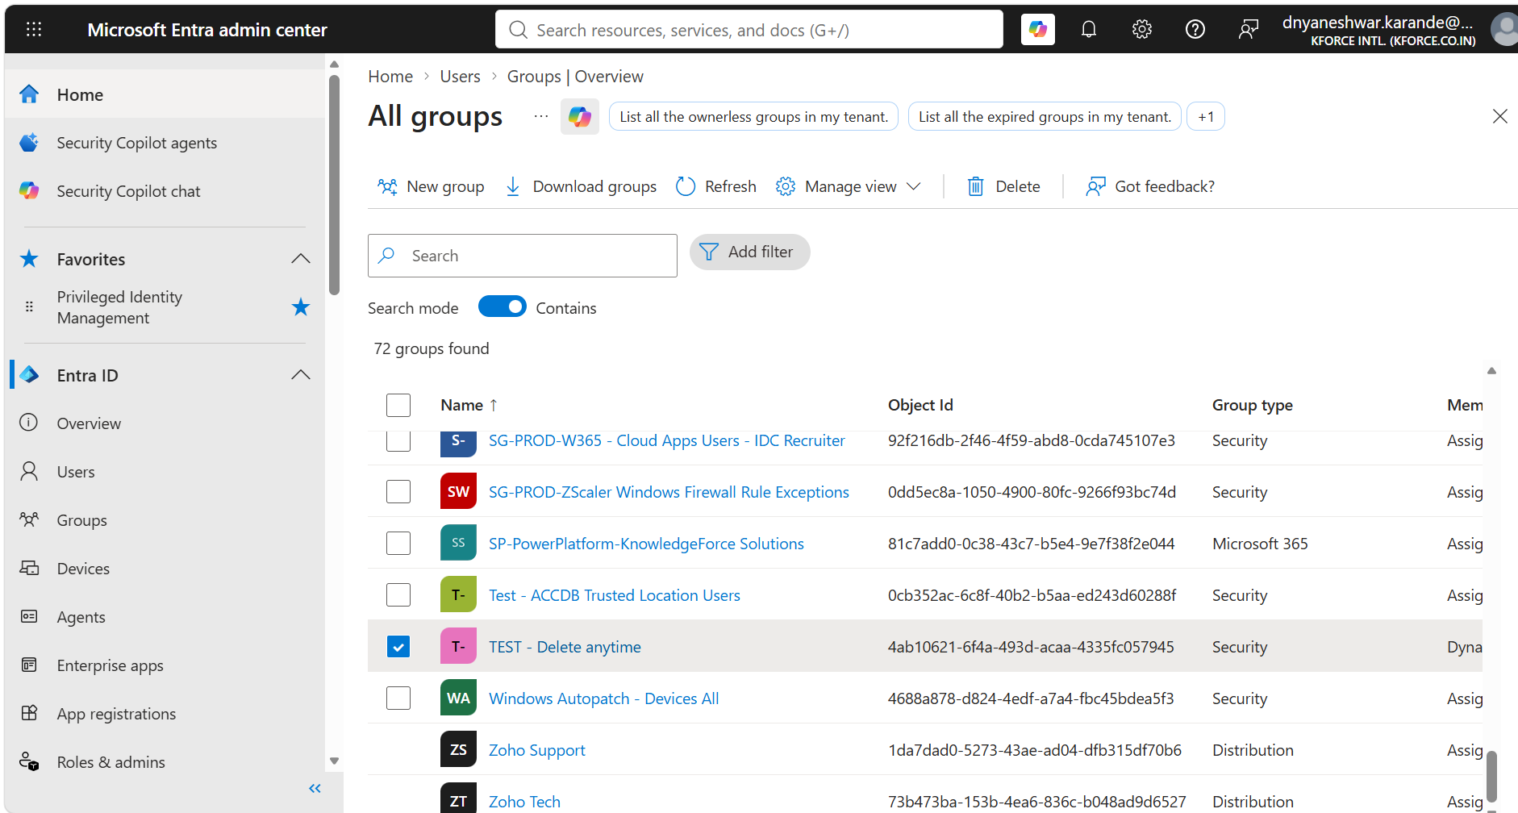
Additional screenshot reference 30. Retained from the attached working document.
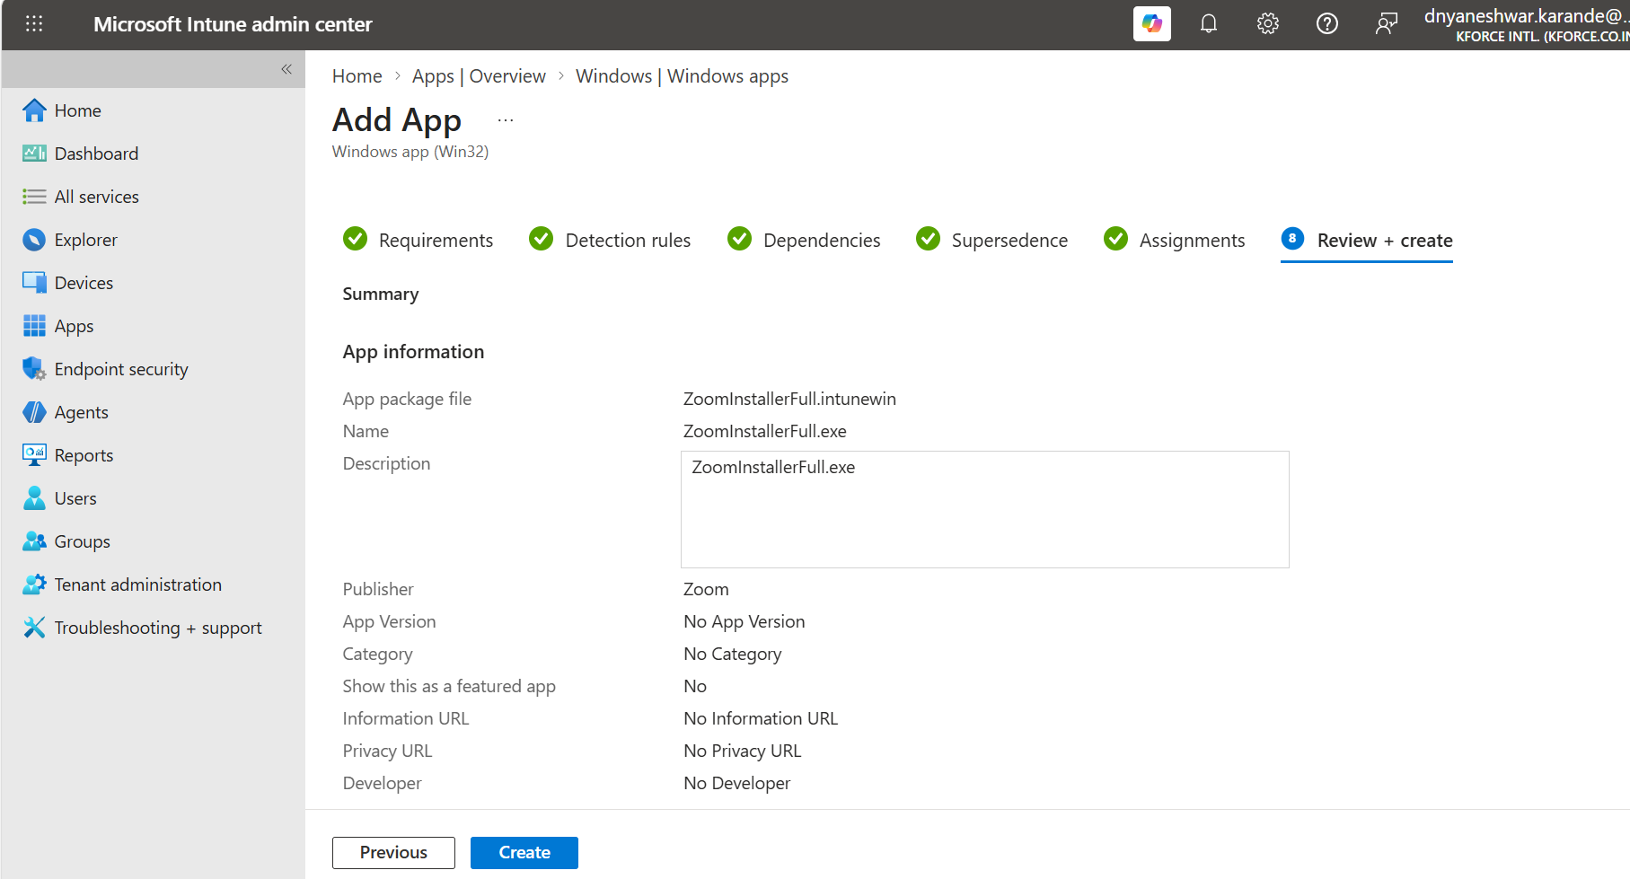
Additional screenshot reference 31. Retained from the attached working document.

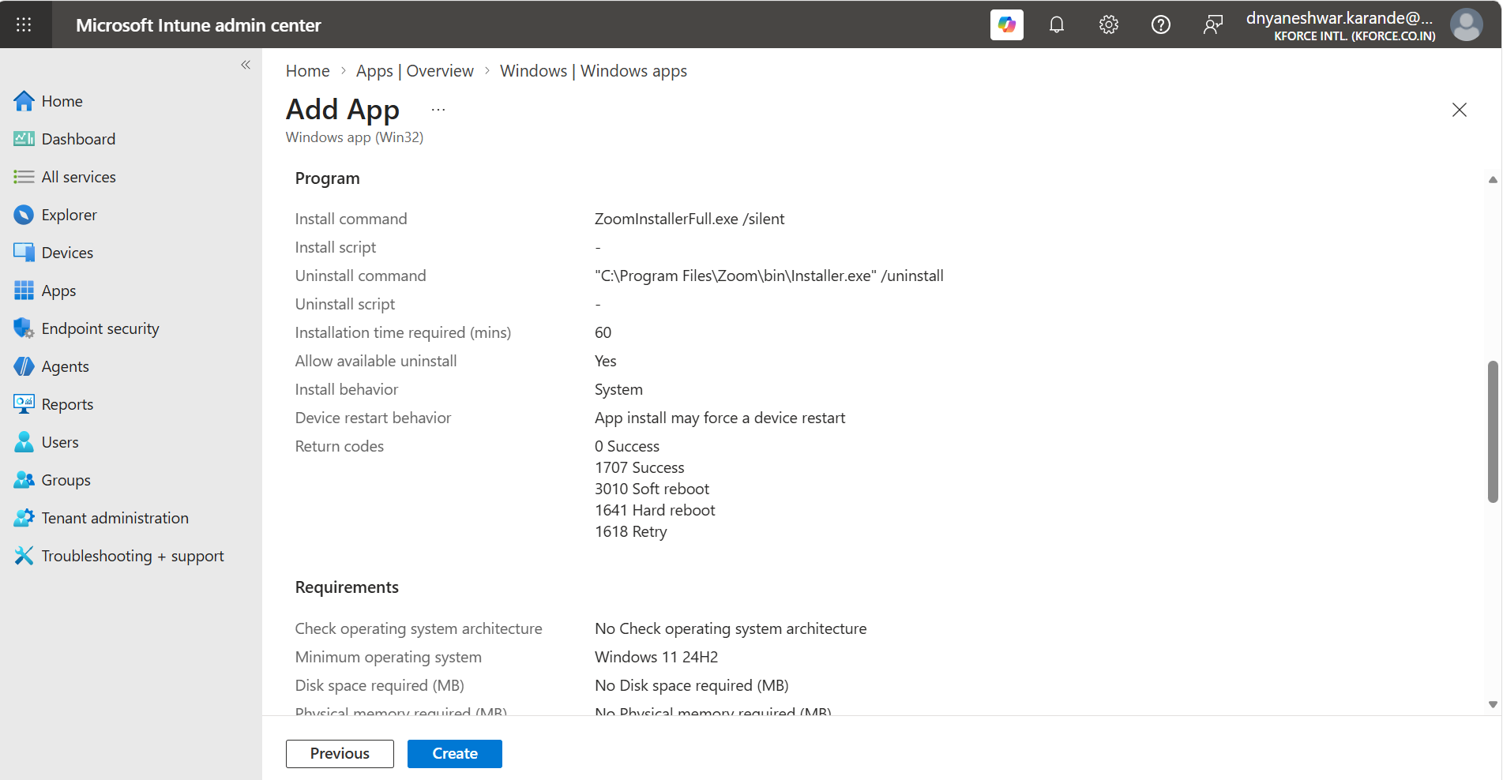
Additional screenshot reference 32. Retained from the attached working document.
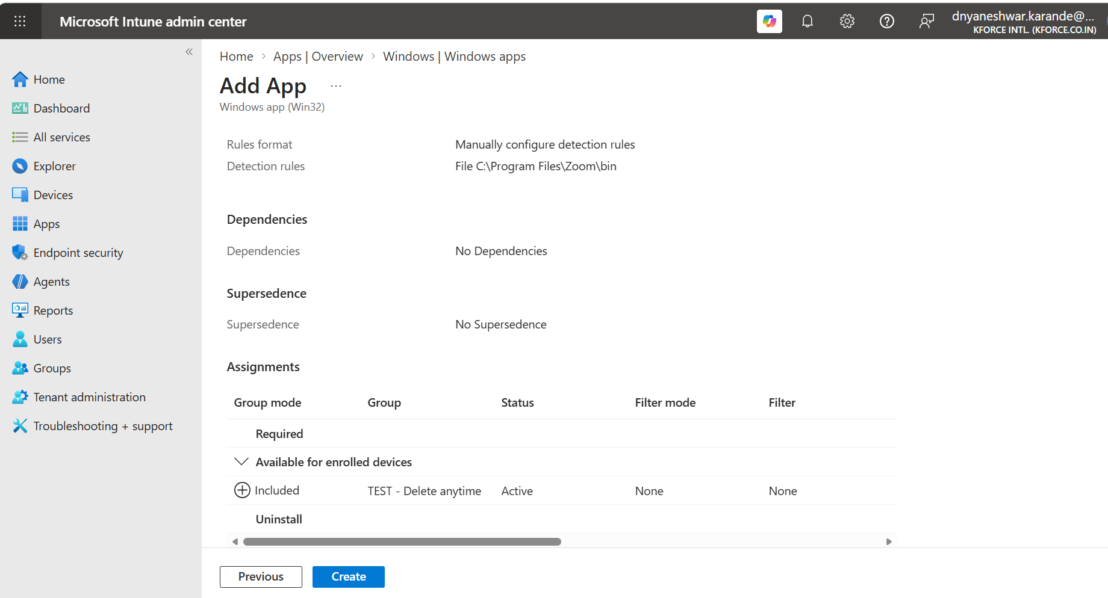
Additional screenshot reference 33. Retained from the attached working document.

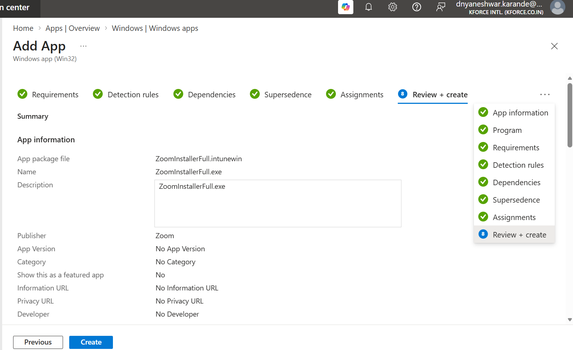
Additional screenshot reference 34. Retained from the attached working document.
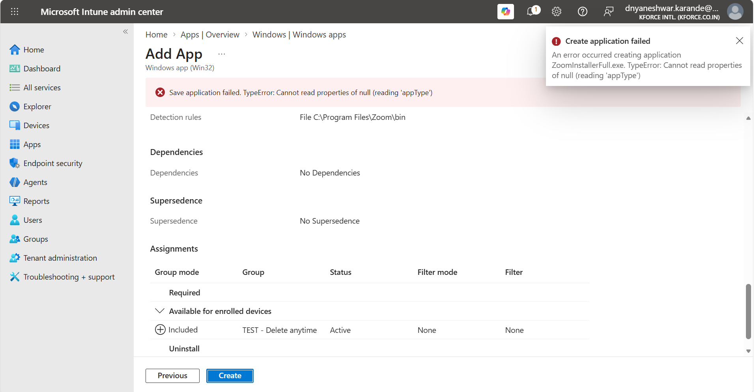
Additional screenshot reference 35. Retained from the attached working document.

19. Official References and Maintenance

19.1 Official references
- Microsoft Learn: Win32 app management in Microsoft Intune - https://learn.microsoft.com/intune/app-management/deployment/win32
- Microsoft Learn: Add, assign, and monitor a Win32 app - https://learn.microsoft.com/intune/app-management/deployment/add-win32
- Microsoft Learn: Prepare Win32 app content for upload - https://learn.microsoft.com/intune/app-management/deployment/create-win32-package
- Microsoft GitHub: Microsoft Win32 Content Prep Tool - https://github.com/microsoft/Microsoft-Win32-Content-Prep-Tool
- Zoom Support: Mass deployment with preconfigured settings for Windows - https://support.zoom.com/hc/en/article?id=zm_kb&sysparm_article=KB0064484

19.2 Review triggers
- Intune portal workflow or field names change.
- Microsoft Win32 Content Prep Tool is updated.
- Zoom installer type, commands, path, or update behavior changes.
- Organizational OS baseline or architecture changes.
- RBAC, app approval, packaging, security, or change-management policy changes.
Operational reminder
Treat this as a master learning and operational guide. For each production app, create a smaller application-specific record that captures the exact installer version, commands, detection, assignment, testing evidence, and rollback plan.

